

UNIVERSITY OF NAIROBI

SCHOOL OF COMPUTING AND INFORMATICS

PLASTIC RIVER POLLUTION DATA COLLECTION SYSTEM

USING RASPBERRY PI

(PRIPOD)

BY

LIGARE LEAH EFFIE ATIENO

A PROJECT REPORT SUBMITTED IN PARTIAL FULFILMENT OF THE REQUIREMENTS FOR THE BACHELOR OF SCIENCE IN COMPUTER SCIENCE AT THE UNIVERSITY OF NAIROBI.

JUNE, 2022

# DECLARATION

I hereby declare that this project report is my own work unless otherwise stated within the text and has not been submitted elsewhere in this or any other institution for any award.

Signature:                                                   Date:

Student’s name:   LIGARE LEAH EFFIE ATIENO

Registration number:   P15/129182/2018

This project report has been submitted as a partial fulfilment of the requirements for the in Degree of Bachelor of Computer Science in the University of Nairobi with my approval as the supervisor.

Signature:                                                   Date:

PROF ELISHA. T. OPIYO.

Department of Computing and Informatics.

# ACKNOWLEDGEMENT

First and foremost I give all glory and gratitude to God for bringing me this far and enabling me to do this project. I am grateful to Prof Elisha Opiyo for the advice and guidance given on this project, to Chemolex for providing content on plastic pollution to add to the website and to family and friends for all the support and encouragement given through the years.

# DEDICATION

This project is dedicated to my parents, relatives and friends for their support given throughout the years and shown in many different ways.

LIST OF ABBREVIATIONS

1.   PRIPOD – Plastic River Pollution Detection System.

2.   NEMA – National Environmental Management Authority.

3.   WARMA – Water Resources Management Authority.

4.   GDP – Gross Domestic Product.

5.   UNEP – United Nations Environmental Program.

6.   DFD – Data Flow Diagram.

7.   AI – Artificial Intelligence.

8.   ML – Machine Learning.

9.   IoT – Internet of Things.

10. IUCN – International Union for Conservation of Nature.

1. OS – Operating System.
2. PC – Personal Computer.
3. AWS – Amazon Web Service
4. VNC – Virtual Network Computer
5. SSH – Secure Shell

# ABSTRACT

About 13 million tons of plastic end up in the oceans each year. This is a worrying fact but even worse is that this number is rapidly growing. An assessment released by UNEP in October 2021, shows that plastic pollution in oceans could more than double by 2030. The effects of plastic pollution are multifaceted and affect numerous spheres of life from the economic, environmental to the social plus has devastating effects on human health. Plastic waste gets in the oceans mainly through rivers. An estimated 80% of global annual ocean plastic pollution (that is about 10.4 million tons) is from rivers, with small urban rivers amongst the most polluting. That is why many solutions try to capture plastics in rivers before they get to the oceans. This is a global tragedy and internationally new technologies are being used to contain this disaster, there is the use of satellite observation on ocean plastics, AI to understand natural systems & big data and data visualization to measure and track earth’s resources. However, most of the technologies such as AI, ML, Blockchain and IoT require data on plastics, which is rare or not available in Kenya. Most of the data we use is accrued internationally. The proposed solution in this report is based on a raspberry pi computer and uses Computer Vision, a branch of AI that enables vision in machines. It uses a raspberry pi camera, connected to the raspberry pi computer that takes a photo of the river and its surroundings every 4 hours, the images taken are then saved as is then used as input data and processed to identify the plastics through template matching. This information is then stored and during the monthly maintenance routines, downloaded from the raspberry pi and uploaded to the Pripod website for easy access. The website also contains articles to raise awareness about plastics and their disposal that is provided by our partners who currently are the Chemolex Company. The methodology used in creating this system is evolutionary prototyping that is flexible enough to allow making changes to the prototype hence enable customer input and improvement without having to remake the prototype from the very beginning. The project is in its preliminary phases of implementation, it has been successful in identification of plastic templates of different kinds such as bottles, sanitizers and masks that are fed to it, though there is still a lot to improve on so as to optimize the product.

TAble of Figures

Figure 1: Plastic production rate 4

Figure 2: Micro plastic cycle 5

Figure 3: Pripod -High Level Design 9

Figure 4: Pripod -project methodology 10

Figure 5: Pripod budget 14

Figure 6: Nairobi River. Kariobangi North 15

Figure 7: River Kirichwa. Kileleshwa 15

Figure 8: plastics collected from Nairobi River. Korogocho slums 16

Figure 9: A garden from a wasted land by plastic. Nairobi River Lakisama. 17

Figure 10: A garden from a wasteland of plastic. Nairobi River. Korogocho slums 17

Figure 11: Plastic Capture Device 18

Figure 12: Plastic Collection Device under maintenance 19

Figure 13: Pripod hardware Schematic 22

Figure 14: Pripod Webapp site map 22

Figure 15: Pripod system flowchart 23

Figure 16: Pripod Use Case Diagram 24

Figure 17: Pripod Sequence Diagram 25

Figure 18: Pripod Level 0 DFD 26

Figure 19: Pripod Level 1 DFD 26

Figure 20: Pripod level 2 DFD 27

Figure 21: The first part of the landing page on the webapp 28

Figure 22: The second part of the landing page on the webapp 28

Figure 23: The third and final part of the landing page on the webapp 29

Figure 24: View river sites page 29

Figure 25: View plastics page 30

Figure 26: Learn page 30

Figure 27: The Raspberry Pi imager 32

Figure 28: Bullseye OS desktop 32

Figure 29: Raspberry pi camera 33

Figure 30: Assembly of case, Phase one 34

Figure 31: Assembly of parts, phase 2 34

Figure 32: Assembly of case. Completion 35

Figure 33: Beginning of index page html 35

Figure 34: End of index page html 36

Figure 35: View river page html 36

Figure 36: View plastic page html 37

Figure 37: Css of webapp 37

Figure 38: End of Css of webapp 38

Figure 39: AWS S3 pripodbkt bucket 38

Figure 40: Landing page (1st section) 43

Figure 41: Landing page (2nd section) 43

Figure 42: Landing page (3rd and last part) 44

Figure 43: Main activities section 44

Figure 44: View river sites page 45

Figure 45: View plastics page. 45

Figure 46: Learn page 46

TABLE OF CONTENTS

DECLARATION i

ACKNOWLEDGEMENT ii

DEDICATION iii

LIST OF ABBREVIATIONS iv

ABSTRACT v

TABLE OF FIGURES vi

CHAPTER 1. INTRODUCTION 1

1.1 Background 1

1.2 Problem definition 2

1.3 Objectives 2

1.3.1 General objective 2

1.3.2 Specific objectives 2

1.4 Project justification 2

1.5 Scope 2

CHAPTER 2. LITERATURE REVIEW 3

2.1 Plastic production 3

2.2 The Micro-plastic Pollution Cycle 4

2.3 The Effects of Ocean Plastic Pollution 5

2.4 The Significance of Data on Plastics 6

2.5 Plastic Detection in Rivers 6

2.6 Applications that collect data on plastics 7

2.7 Raspberry pi 7

2.8 Computer Vision 7

2.9 Proposed Solution 8

2.10 High Level Design 9

CHAPTER 3. METHODOLOGY 10

3.1 System methodology 10

3.1.1 Actions to be taken at each step of the methodology 10

3.1.2 Justification of the methodology 12

CHAPTER 4. SYSTEM ANALYSIS AND DESIGN 13

4.1 Feasibility studies 13

4.2 Data gathering 14

4.3 Requirements elicitation 20

4.3.1 Functional and non-functional requirements 20

4.4 System design 22

4.4.1. Hardware Schematic 22

4.4.2. Pripod webapp sitemap 22

4.4.3. Flowchart 23

4.4.4. Use Case Diagram 24

4.4.5. Sequence diagram 25

4.4.6. Data Flow Diagrams 26

4.5 User Interface design 28

CHAPTER 5. IMPLEMENTATION AND TESTING 31

5.1 Implementation 31

5.1.1 Resources 31

5.2 Testing 39

CHAPTER 6. CONCLUSION 40

6.1 Achievements 40

6.2 Limitations 40

6.3 Future plans 40

6.4 Recommendations 40

6.5 Conclusion 40

REFERENCES 41

APPENDICES 43

A. USER MANUAL 43

B. GLOSARY 47

# INTRODUCTION

## Background

Pollution as defined by Oxford dictionary is the presence in or introduction into the environment of a substance which has harmful or poisonous effects. Plastic pollution in oceans is a global endemic with multiple effects on the environment, animals, coastal tourism, food security and people. Plastic production will increase by 40% in the next 10 years. If we don’t do anything about the plastic soup, that is thehuge accumulation of plastic waste that has been thrown away and has ended up in the ocean, oceans will carry more plastic than fish (by weight) by 2050. The United Nations warns that marine life will be irreparably destroyed (Plastic Soup Foundation).

Plastic is a synthetic organic polymer made from petroleum. Its introduction provided society with a material that has limitless possibilities. Due to its beneficial characteristics (inexpensive, durable, lightweight, abundant, and can be produced in any desired shape), the popularity of plastics drastically increased during the 20th century and its production is still on the rise. Initially, plastics were mainly used for long-lasting items. Nowadays, a growing portion of plastics are used for single-use purposes with properties ideally suited for a wide variety of applications including: packaging, building & construction, household equipment, sports equipment, vehicles, electronics and agriculture (Tim Van Emmerick). Over 300 million tons of plastic are produced every year, half of which are used to create single-use items. If discarded improperly, plastic waste can cause a lot of harm and destruction. Initially, it was a common belief that plastics do not dissolve but through a study in 2009, scientists later discovered that some plastics actually decompose rapidly in the ocean leaking potentially toxic chemicals into the seas, threatening environments, ocean animals and us humans too (Barry).

The **main sources of plastic debris found in the ocean are land-based**, coming from urban and storm water runoff, sewer overflows, littering, inadequate waste disposal and management, industrial activities, tyre abrasion, construction and illegal dumping which are then carried to the ocean by rivers that feed them (IUCN). In research published in Science Advances, scientists found that 80 percent of plastic waste in oceans is distributed by more than 1,000 rivers across the globe. They also found that most of that waste is carried by small rivers that flow through densely populated urban areas (Parker, Plastic gets to the oceans through over 1,000 rivers). Although Kenya has taken many strides in helping the global fight against plastics, including a ban on the production, sale and use of plastic carrier bags in 2017 for which Kenya got international recognition and is considered one of the sternest in the world, more needs to be done. With more recent technology at our finger tips a lot more can be done.

## Problem definition

Plastic pollution in oceans is soon becoming a global environmental disaster, affecting multiple sectors and most importantly our health. Plastic pollution in the oceans is mainly driven by the waters that feed them, the rivers. Data on plastics is a vital tool in fighting this endemic, however in Kenya, we heavily rely on data that is collected outside the country to fight plastic pollution within. This may prove to be ineffective as though plastic is globally used, different people use and dispose of it in varied ways.

## Objectives

### General objective

To develop a Plastic River Pollution Data Collection System using Raspberry pi that will help collect data and subsequently aid the clean-up of the environment.

### Specific objectives

1. Gather requirements for the system.
2. Design the system (the camera module, the web application and the integrated system.)
3. Create a prototype (assemble raspberry pi & camera parts, implement web application that will be used to display the photos and create awareness on plastic pollution.)
4. Test and evaluate the system.
5. Deploy the website.

## Project justification

The project will provide a means to collect data on plastics that will be used in performing research such as the different types of plastics found in various places.

The data collected and research done may be used for more informed policy making and other actions to be taken against plastics.

The project will help the country have cleaner waters hence reducing illnesses caused by and related to ocean plastic pollution also, as a ripple effect, increase productivity and better the economy.

The project will over time help the nation attain both national and global environmental goals such as several of the United Nations Sustainable Development Goals.

## Scope

The system will cover rivers in Nairobi for now and hopefully scale to cover all rivers in the nation, continent and through the world in future.

My target audience are the organizations involved in the river clean-up such as Chemolex and the bodies in charge of the welfare of rivers such as NEMA and WARMA.

# LITERATURE REVIEW

This section of the report contains a written overview of the main topics related to the problem, related work and the solution.

## Plastic production

Initially plastics were seen to be a blessing but with time as technology improved, their production rose, became more unnatural and disposal became more reckless, they became a curse to the society. When we think of "plastics," what we're really think of are synthetic polymers. Polymers are substances made from long chains of molecules — they can be found in nature, such as the cellulose in plants and are bio-degradable. However synthetic polymers are generally designed to be durable and flexible; hence why they are known as "plastic." Plastics are often made of carbon provided by fossil fuels like petroleum, although that was not always the case. The first synthetic polymer, created in 1869 by American inventor John Wesley Hyatt, combined cellulose from cotton with a waxy substance known as camphor that usually comes from trees. This became known as celluloid, but it was only a partially synthetic plastic. The first plastic to contain no molecules found in nature was invented nearly four decades later, in 1907, by a Belgian chemist Leo Baekeland who was trying to find a way to mass produce electrical insulators. Business leaders quickly realized that his creation, known as Bakelite, could be used to make a wide range of products. By the time America needed to ramp up industry to fight in World War II, the plastics revolution had taken off (Rozsa). The amount of plastic that is produced in the world every year has increased explosively in just a human lifetime. From 2 million tons in 1950 to 368 million tons in 2019. These are the figures from the plastics industry itself, but they do not include synthetic fibres so the real production is a lot higher. More than half the total amount of plastic produced was only brought to market after 2000. The expectation is that the production will further increase to about 600 million tons in 2025. This is roughly twice the total weight of the world’s population today! (Plastic Soup Foundation).

The significant growth in plastics is mostly due to the growing population, especially in developing countries, per capita use is on the rise. This has also greatly been expedited by the COVID-19 pandemic that made it almost completely mandatory to have masks of various types, sanitizer bottles and different types of plastics produced in large masses. Also, falling oil prices have made production of virgin plastic cheaper than ever. Demand for consumer goods sheathed in disposable, single-use plastic has soared as shoppers seek protection from the virus. Still, Martin Stuchtey, SYSTEMIQ’s co-founder and managing partner sees a silver lining. Before the pandemic, industry resisters argued that systemic change was too big, too difficult, too expensive, and time-consuming to pull off. COVID-19 put the lie to those arguments after shortages of toilet paper and other goods scrambled the supply system and upended shipping lines. (Parker, Plastic trash flowing into the seas will nearly triple by 2040 without drastic action)

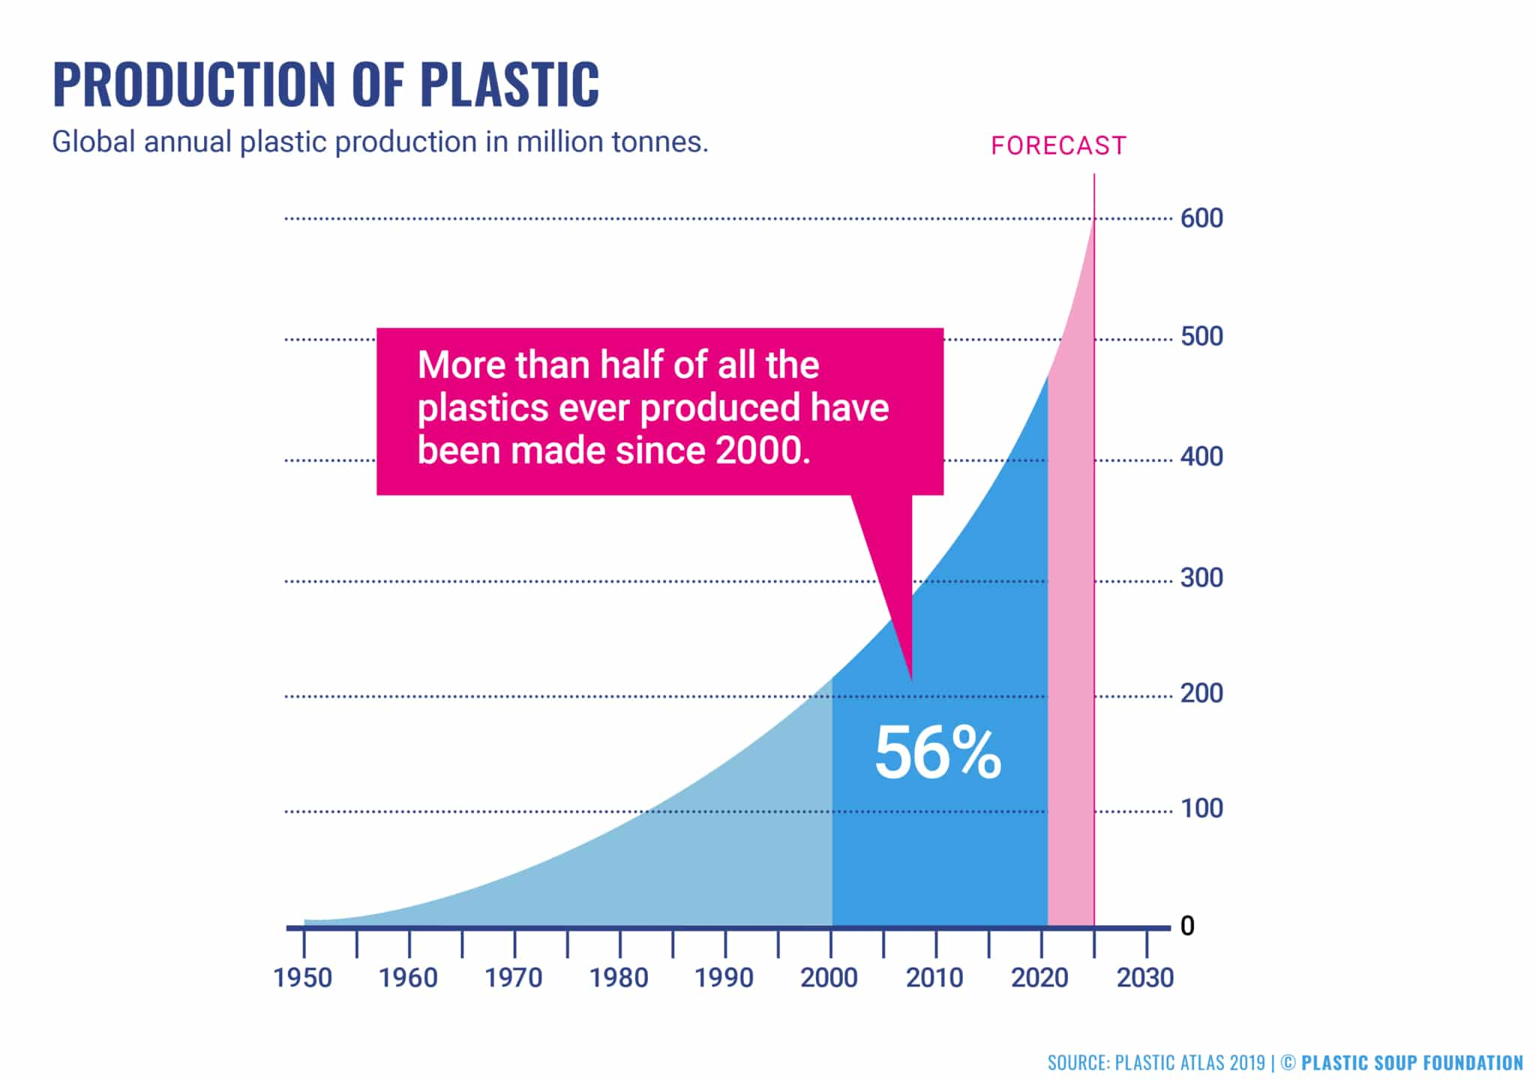

Figure 1: Plastic production rate

The significant growth in plastics is mostly due to the growing population, especially in developing countries, per capita use is on the rise. This has also greatly been expedited by the COVID-19 pandemic that made it almost completely mandatory to have masks of various types, sanitizer bottles and different types of plastics produced in large masses. Also, falling oil prices have made production of virgin plastic cheaper than ever. Demand for consumer goods sheathed in disposable, single-use plastic has soared as shoppers seek protection from the virus. Still, Martin Stuchtey, SYSTEMIQ’s co-founder and managing partner sees a silver lining. Before the pandemic, industry resisters argued that systemic change was too big, too difficult, too expensive, and time-consuming to pull off. COVID-19 put the lie to those arguments after shortages of toilet paper and other goods scrambled the supply system and upended shipping lines. (Parker, Plastic trash flowing into the seas will nearly triple by 2040 without drastic action)

## The Micro-plastic Pollution Cycle

Plastics are very handy and have multiple uses in almost all fields from the manufacturing industry, medical, food, even education industry however they can be quite harmful as an end result when disposed of improperly. Under the influence of solar UV radiation, wind, currents and other natural factors, **plastic breaks down into small particles** called micro-plastics (particles smaller than 5 mm) or nano-plastics (particles smaller than 100 nm). The small size makes them **easy for marine life to ingest**. (IUCN) These micro plastics then make their way into our food through human activities like fishing they are then consumed, more plastic is disposed of and the cycle continues.

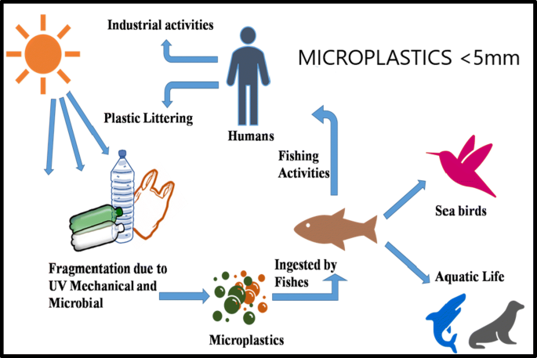

Figure 2: Micro plastic cycle

Recent studies have also shown that micro plastics also dissolve into the atmosphere and hence affects even those who take no sea food and other land creatures.

## The Effects of Ocean Plastic Pollution

Ocean plastic pollution has multiple effects, some of which are listed below.

On marine ecosystems

The most visible impacts of plastic debris are the ingestion, suffocation and entanglement of hundreds of marine species. Marine wildlife such as seabirds, whales, fish and turtles mistake plastic waste for prey; most then die of starvation as their stomachs become filled with plastic. They also suffer from lacerations, infections, reduced ability to swim, and internal injuries. Floating plastics also help transport invasive marine species, thereby threatening marine biodiversity and the food web. (IUCN)

On tourism

The plastic waste damages the aesthetical value of the ocean sites making it less interesting to view and having less people coming to view the sites. Cleaning up will also take an economic toll on those paying to clean and as more marine animals succumb to plastics, there will be less biodiversity which will chase tourists away.

On food security

Other than being in the atmosphere and minimally affecting plant processes like photosynthesis, the soil that our plants are planted on contain, trace amounts of micro-plastics, which mainly comes from the ocean waters, which could then multiply in the coming years and cause yields to significantly reduce.

On healthcare

On human beings, the chemical effects are especially problematic at the decomposition stage. Additives such as phthalates and Bisphenol A (widely known as BPA) leach out of plastic particles. These additives are known for their hormonal effects and can disrupt the hormone system of both vertebrates and invertebrates alike. In addition, nano-sized particles may cause inflammation, traverse cellular barriers, and even cross highly selective membranes such as the blood-brain barrier or the placenta. Within the cell, they can trigger changes in gene expression and biochemical reactions, among other things. The long-term effects of these changes have not yet been sufficiently explored. “However, it has already been shown that when passing the blood-brain barrier nano-plastics have a behaviour-changing effect in fish,” according to the Leibnitz Institute of Freshwater Ecology and Inland Fisheries. (Thompson)

## The Significance of Data on Plastics

Kenya has made significant steps in the fight against plastic. In response, many political and business leaders have committed to ending the flow of plastic into nature. However, critical gaps in data provision exist. Simply put, we can’t manage what we can’t measure. Many of the upcoming technologies offer promising prospects but most if not all of them require data so as to help in the fight against ocean plastics. This data can be used to: Find where most plastics are disposed of; Find what material most plastics are and the area where they are located; Make policies; Perform research; Create more efficient methods to fight pollution.

## Plastic Detection in Rivers

Robovision by DEME organization in Belgium. Uses cameras and AI to identify waste in the river Scheldt after which an autonomous ship collects it.

Using drones to detect plastic in waters. A study done in the Netherlands by Marlein Geraeds, a masters student in Hydraulic Engineering.

Automated River Plastic Monitoring Using Deep Learning and Cameras. A study by Colin van Lieshout, Kees van Oeveren, Tim van Emmerik and Eric Postma in The Netherlands. It is an automated method for monitoring plastic pollution that overcomes the problem of feasibility of scaling to long-term monitoring at multiple locations.

## Applications that collect data on plastics

Marine Debris Tracker, is an open data citizen science movement, powered by Morgan Stanley, developed by Southeast Atlantic Debris Initiative and hosted at the University of Georgia. The app is used by people to report litter wherever it is found.

An application by a youth group in Kisumu that is under development where the user will upload the number and type of plastic collected in their specific location and through GIS technology, will be directed to the nearest recycling plant by the user.

Wastebase DATA owned by Cameron Smith in Mozambique is a crowdsourced solution that is a free online platform where individuals can scan a bottle's barcode to instantly upload data about that bottle to the platform. The product is then linked to information about the company and brand that owns it, as well as data about material type (PET/HDPE), volume, weight, and location.

River Plastic Survey by The Ocean Cleanup in the Netherlands where users log in to their accounts on the app and choose a survey duration of 5 to 60 minutes to record the plastic items they identify on the water surface.

Ocean Plastic Survey, by The Ocean Cleanup in the Netherlands where users record the floating plastic debris encountered while sailing, travelling, or working on the ocean, which is then uploaded to a global database.

## Raspberry pi

The Raspberry Pi Foundation is a UK-based charity that works to put the power of computing and digital making into the hands of people all over the world. We do this so that more people are able to harness the power of computing and digital technologies for work, to solve problems that matter to them, and to express themselves creatively (The Raspberry Pi foundation). **The Raspberry Pi story started in 2006 with the creation of the first prototypes inspired from the BBC Micro by** Eben Upton, a British engineer**.** Raspberry’s name was mainly to follow the trend as before there was Apple, Acorns and Apricot computers, but it was also a funny reference to the expression ‘blowing a raspberry’, said it was an allusion to the project nature at this time according to Eben Upton. **The “Pi” part is a reference to the Python part of the first devices created.** These devices started with a terminal prompt where you needed to type any Python code to do what you want. This was to make the difference with other computers running with BASIC. (Raspberry Pi Tips).

## Computer Vision

Computer vision is a field of AI that enables computers and systems to derive meaningful information from digital images, videos and other visual inputs — and take actions or make recommendations based on that information. AI enables computers to think, computer vision enables them to see, observe and understand. Computer vision works much the same as human vision, except humans have a head start. Human sight has the advantage of lifetimes of context to train how to tell objects apart, how far away they are, whether they are moving and whether there is something wrong in an image. Computer vision trains machines to perform these functions, but it has to do it in much less time with cameras, data and algorithms rather than retinas, optic nerves and a visual cortex. Because a system trained to inspect products or watch a production asset can analyse thousands of products or processes a minute, noticing imperceptible defects or issues, it can quickly surpass human capabilities. Computer vision is used in industries ranging from energy and utilities to manufacturing and automotive – and the market is continuing to grow. It is expected to reach USD 48.6 billion by 2022 (IBM).

OpenCV is a library of programming functions mainly aimed at real-time computer vision. Originally developed by Intel, it was later supported by Willow Garage then Itseez. The library is cross-platform and free for use under the open-source Apache 2. (Wikipedia)

## Proposed Solution

The proposed solution is a raspberry pi based system named Pripod. The system will use a picam (the raspberry pi camera) to take photos of the river site every four hours. The photo will be stored in an SD Card to allow for any future analysis that may be required after storage other than template matching. This same photo will then be copied and processed using OpenCV to identify the plastics through template matching where the template, a photo of the plastic to be identified will be added to the raspberry pi computer before-hand. The result will be stored in the raspberry pi using the same SD Card. This data (the photo and the result) will then be downloaded from the raspberry pi computer during the monthly routine check-ups and uploaded to the Pripod website where it can easily be accessed by anyone who has internet connectivity. The website also contains articles to raise awareness about plastics and their disposal that is provided by our partners, currently the Chemolex Company.

## High Level Design

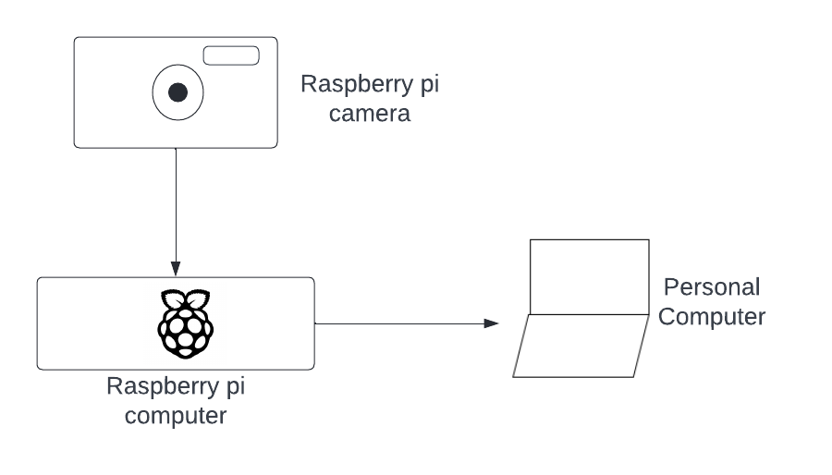

Figure 3: Pripod -High Level Design

# METHODOLOGY

A methodology is a logical process for constructing a system that describes the activities involved in structuring, planning, and controlling the process of developing a system.

## System methodology

In this system evolutionary prototyping methodology is to be used. Evolutionary prototyping methodology is a process where a developer begins with using the best understood needs of a user, according to them, to create a prototype of the system which is presented to the user and if the user is satisfied, it is used as the final product if not, the prototype is continually refined until the user is satisfied with the prototype which is then used as the final product. It combines both the iterative and waterfall methodologies in its design and is shown in the below diagram.

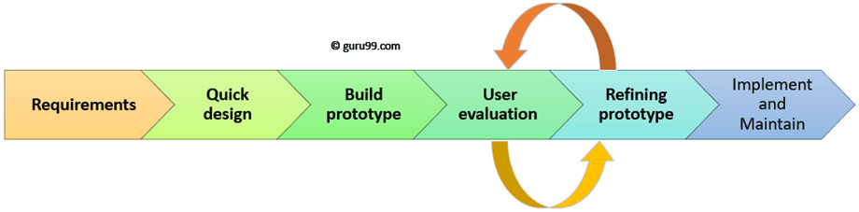

Figure 4: Pripod -project methodology

### Actions to be taken at each step of the methodology

**Requirements**

Requirements are to be gathered from various sources for the system as a whole and the different modules of the system. For the different modules of the system, that is the raspberry pi camera and computer together with the website only document review was done to research on how they can be designed and implemented.

For the integrated system, information was elicited system by observation, conducting document reviews and interviews.

1. Observation, it involved viewing particular instances such as how plastic pollution has affected rivers and activities such as river Kirichwa that we live next to and passes through schools such as Makini and campuses such the Chiromo UoN Campus, the observations were then recorded.
2. Document review, this was done by going through different books, journals and sites on the internet with information related to the project.
3. Interviews. The interviews we conducted informally, mostly through calls and holding conversations with different stake holders of the system by asking them about their views on the ocean plastic pollution problem and the solution that is to be created.

The following were the interview questions.

1. What do you think of the condition of rivers in Kenya in regard to plastic pollution?
2. How do you think the condition of plastics in the rivers and ocean plastic pollution can be improved?
3. How does river plastic pollution affect you?
4. Who provides data on plastics in Kenya?

**Quick design**

Using the gathered requirements a system was designed to solve the problem at hand.

A design for the camera module, the web application module and the integrated system was made from the gathered requirements. These designs are shown in section 4.4 of this report.

**Build prototype**

By following the given design, a system was implemented.

The parts of the raspberry pi computer & the camera module were assembled, an Open CV program to classify the plastics was made and implemented on the raspberry pi computer, a web application was created then deployed to the Microsoft Azure cloud so as to display the data and raise awareness and the different modules were integrated to form a system.

**User evaluation**

The proposed system was then tested and feedback collected.

Three types of tests were used for user evaluation: Unit Testing; Component Testing and System Testing.

In Unit Testing, each module that forms part of the system was tested individually at the end of its implementation to ensure that they are error free and gives the required results by running the various programs in each module.

In Component Testing, each component, which is made of different modules was tested individually at the end of the module’s implementation to ensure it is error free and gives the required results by running the component as a whole.

In System Testing, The system which is made of different components was tested at the end of the components’ implementation to ensure it is error free and gives the required results by running the system as a whole. The system was also given to some users in the target market for them to test the system and give feed-back.

**Refining prototype**

Feed-back from users was used to make some necessary changes.

**Implement and maintain**Based on the feedback from the users, the website was deployed and will continually be refined to improve it with time.

### Justification of the methodology

The methodology allows the developer to assert that the needs of the system’s users are met including any changes that may be required during the production of the system, by continuous communication with them and showing them the prototype to approve before deploying it, hence including the user. It also allows for the prototype developed to be used in creating the final product, even after making numerous changes hence saving on the time and resources of the developer compared to creating the system from scratch in case of changes.

# System Analysis AND DESIGN

System analysis is the process of studying a system so as to understand its goals and how they can be achieved in a more efficient way. This includes various feasibility studies, gathering of data and identifying requirements. After system analysis the next step is to design the system that is to be implemented so as to meet the requirements. This phase comprises of defining elements of a system such as its modules, architecture, components and the different interfaces based on the specified requirements.

## Feasibility studies

These are studies done to determine the practicality of the proposed system, and whether to proceed in building the system or not. They include the following:

#### Technical Feasibility

This study is done to determine whether or not the system can be supported by the existing technology.

The following resources will be required for the proposed system:

Software:

* Raspberry Pi imager to install the raspberry pi OS on the SD Card.
* Bullseye OS. This is the raspberry pi operating system.
* VNC viewer to view the raspberry Pi OS interface from my PC.
* Open CV to create the model that will be used to classify plastics.
* Django to create the web application that will be used to store and display the photos & provide a platform to raise awareness.
* Azure to host the created web application.
* AWS S3 buckets to host static files.

Hardware

* A raspberry pi 4 kit (preferably the Canakit that contains all small additional parts such as the connecting wires and the SD card for memory).
* A raspberry pi 4 case compatible with the fan and camera.
* A raspberry pi 4 compatible camera (preferably the Arducam).
* A PC.

All the technical requirements for the project, listed above can be met and the expertise required is readily available.

#### Economic Feasibility

This study is done to establish the costs involved with the project and compare that to the benefits. The cost incurred in building the system was found to be as follows, with the expertise freely available. The benefits of the system, which mainly are it could lead to plastic pollution eradication that will save millions in Kenya also create a healthier and happier society.

|  |  |  |
| --- | --- | --- |
| **CATEGORY** | **ITEM** | **COST**(from Amazon) |
| **HARDWARE** |  | Ksh 15, 645 |
|  | Raspberry pi 4 kit(Canakit) | Ksh 13, 390 |
|  | Arducam | Ksh 1450 |
|  | Raspberry pi 4 case compatible with fan and camera (Yahboom case) | Ksh 805 |
| **SOFTWARE** |  | Ksh 0 |
|  | Raspberry Pi imager | Ksh 0(Is open source) |
|  | VNC Viewer | Ksh 0 (Is opensource) |
|  | Open CV | Ksh 0(Is open source) |
|  | Django | Ksh 0(Is open source) |
|  | Amazon s3 bucket | Ksh 0(Currently sponsored) |
|  | Microsoft Azure | Ksh 0(Currently sponsored) |
| **TOTAL** |  | Ksh 14, 840 |

Figure 5: Pripod budget

#### Schedule Feasibility

This study is done to specify how long the project will take and if the project can be done within the set time frame. The project would take 5 months to build, which is within the set time frame.

#### Operational Feasibility

This is a study done to measure how well a proposed system solves the problems, and takes advantage of the opportunities identified during scope definition and how it satisfies the requirements identified in the requirements analysis phase of system development. This was done by sharing the design of the system with a target user, who approved of the system.

## Data gathering

With the purpose of getting information that was valuable to the building of this system the results of the methods used in the requirements phase were as follows:

Observation

The rivers visited, that is River Kirichwa and River Nairobi were found to be heavily polluted with plastics of different kinds, especially where the surroundings were densely populated. Also there was some river clean-up and land rehabilitation activities organized by Chemolex noted.

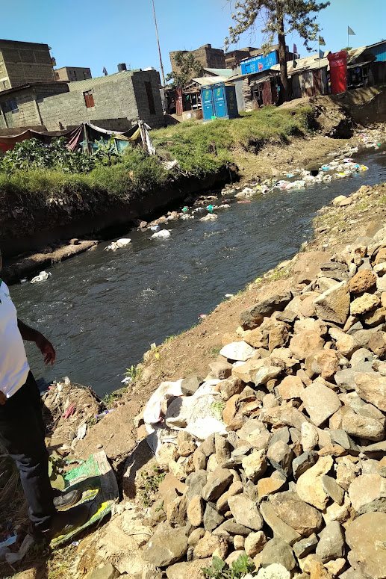

Figure 6: Nairobi River. Kariobangi North

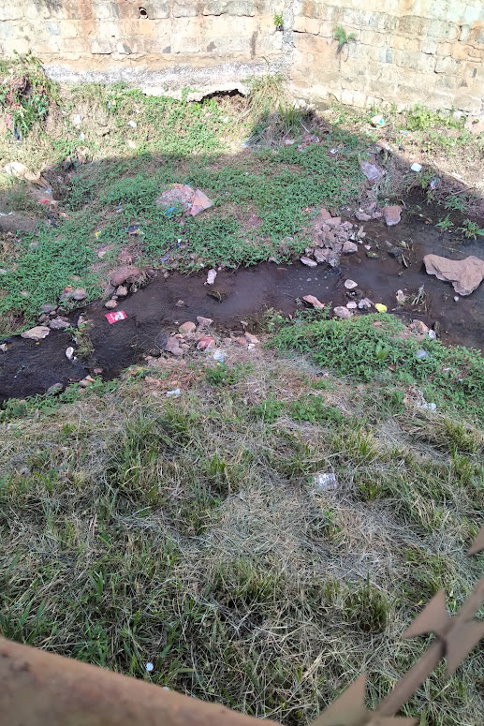

Figure 7: River Kirichwa. Kileleshwa

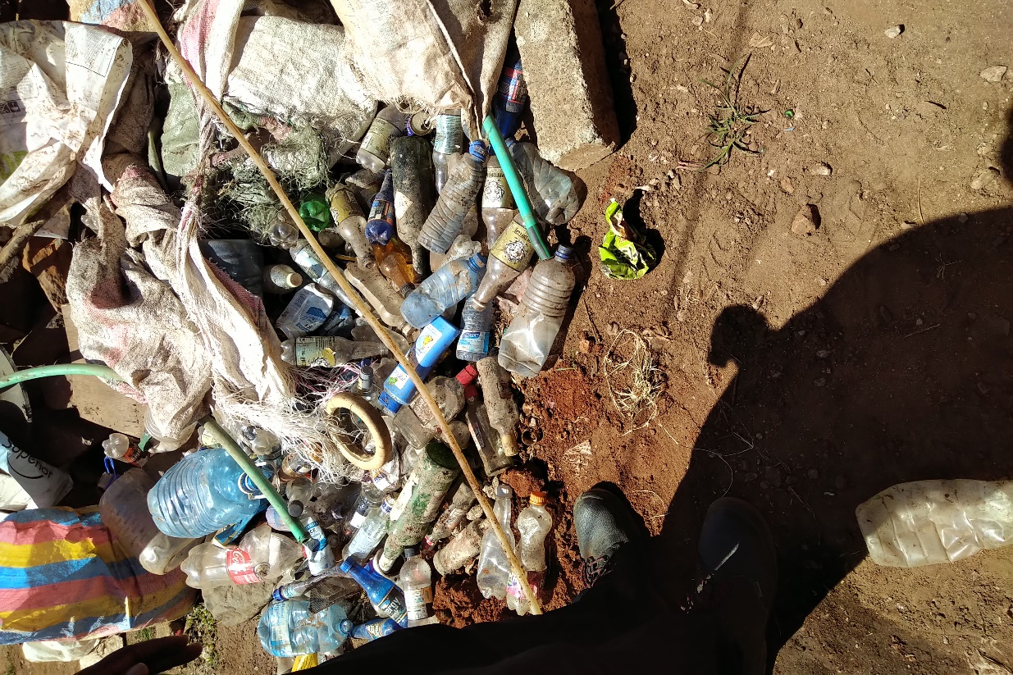

Figure 8: plastics collected from Nairobi River. Korogocho slums

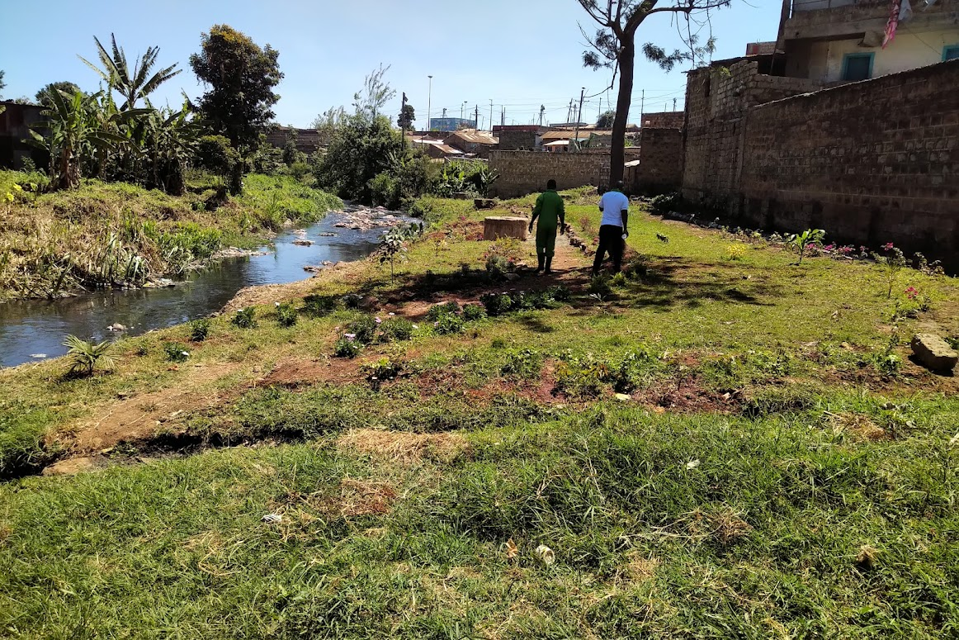

Figure 9: A garden from a wasted land by plastic. Nairobi River Lakisama.

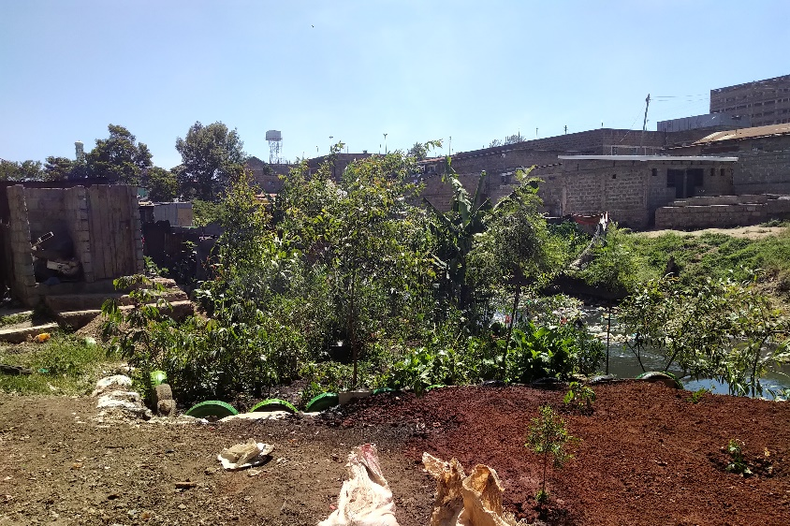

Figure 10: A garden from a wasteland of plastic. Nairobi River. Korogocho slums

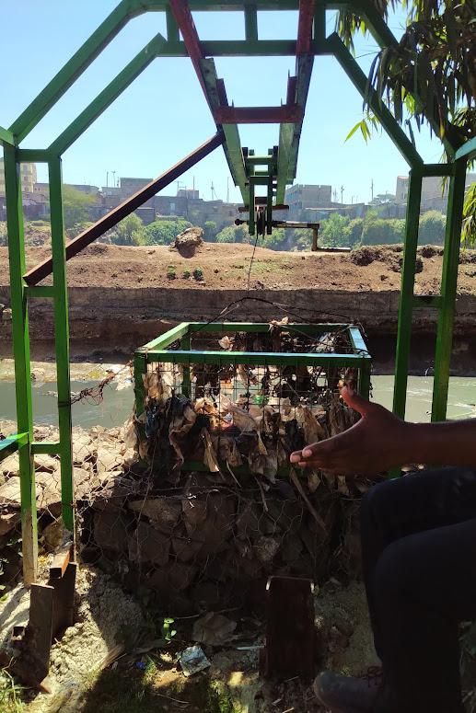

Figure 11: Plastic Capture Device

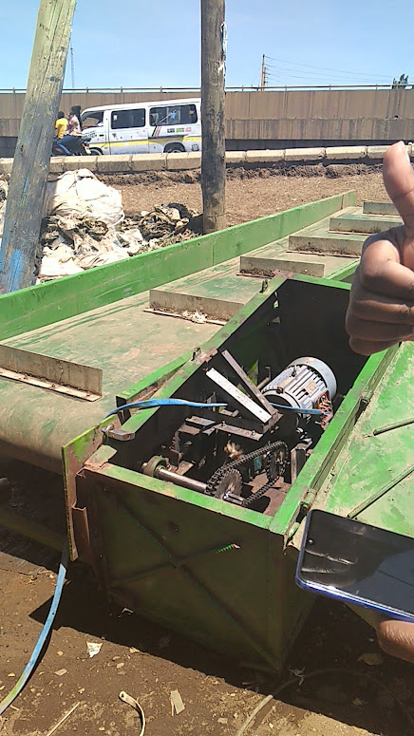

Figure 12: Plastic Collection Device under maintenance

Document review

I found that ocean plastic pollution, mostly fed by riverine plastic pollutions a growing problem that has a myriad of effects in our lives, that technology can be and is being used to combat plastics and that data on plastics is needed in Kenya so as to fight the plastic pollution around us. More of my document review is covered in my literature review, found in chapter 2 of this report.

Interview answers

Below is a summary of the answers my interview questions that are documented in my methodology in chapter 3 of this report:

1. Condition of rivers is really bad, they can be very smelly at times, have plastics of various types in them and most look bad.
2. Cleaning the rivers, making people stop throwing trash into and around the river, making stricter policies on throwing trash anywhere, recycling them, educating the masses and using chemicals to turn plastic into a safe element in water bodies.
3. (Most answers here are for general river pollution) There used to be animals like small fish that would attract different kinds of birds to the river and it would be nice and relaxing to watch them but they don’t come any more. my hospitality is affected as I feel embarrassed to have my visitors outside in my compound when the river is smelling bad; Food security, as I can’t be sure what plants are grown with river water with all its pollutants; Health because at times I can’t get some fresh air as the city has smoke and my residence has the river smell and at times end up suffering from severe headaches.
4. Most did not know, others said from plastic manufactures, people from river cleaning companies like Chemolex told me that they make some themselves and from partners in other parts of the world.

These were the questions:

1. What do you think of the condition of rivers in Kenya in regard to plastic pollution?
2. How do you think the condition of plastics in the rivers and ocean plastic pollution can be improved?
3. How does river plastic pollution affect you?
4. Who provides data on plastics in Kenya?

## Requirements elicitation

Requirements elicitation is the process of doing research and acquiring requirements of a system from the various stake holders such as the system owner and users.

## Functional and non-functional requirements

Functional requirements

1. Taking photos of the river at the required time.
2. Keeping a correct record of unaltered photos.
3. Detecting different types of plastics and providing accurate data on them.
4. Produce correct and accurate records when required.
5. Display the data collected.
6. Raise awareness on ocean plastic pollution.

Non-functional requirements

1. Reliability - system should provide reliable data.
2. Availability – system should be ready to be used when needed.
3. Usability – the system should be easy to use.
4. Performance – there should be production of good images, efficient processing, storage and display together with a fast response rate by the website on commands.
5. Maintainability – the system should be simple to maintain incurring the least amount of costs for maintenance.

## System design

The following diagrams and images show the design of the system:



### Hardware Schematic

A Hardware Schematic is a diagram that shows the hardware that will be used and how they will be connected together.

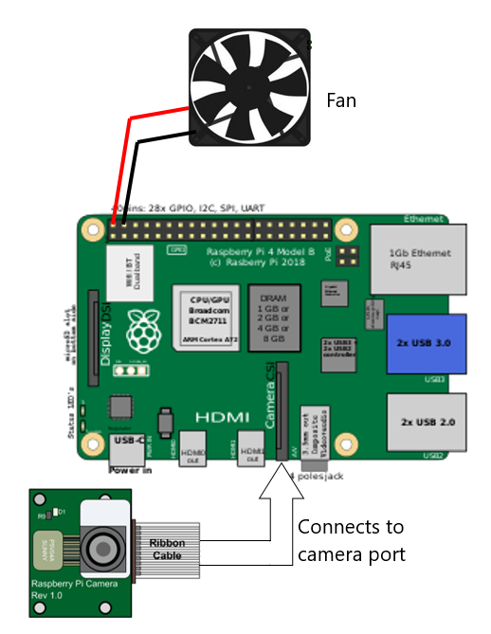

Figure 13: Pripod hardware Schematic

### Pripod webapp sitemap

A sitemap is an organized list of webpages within a certain domain.

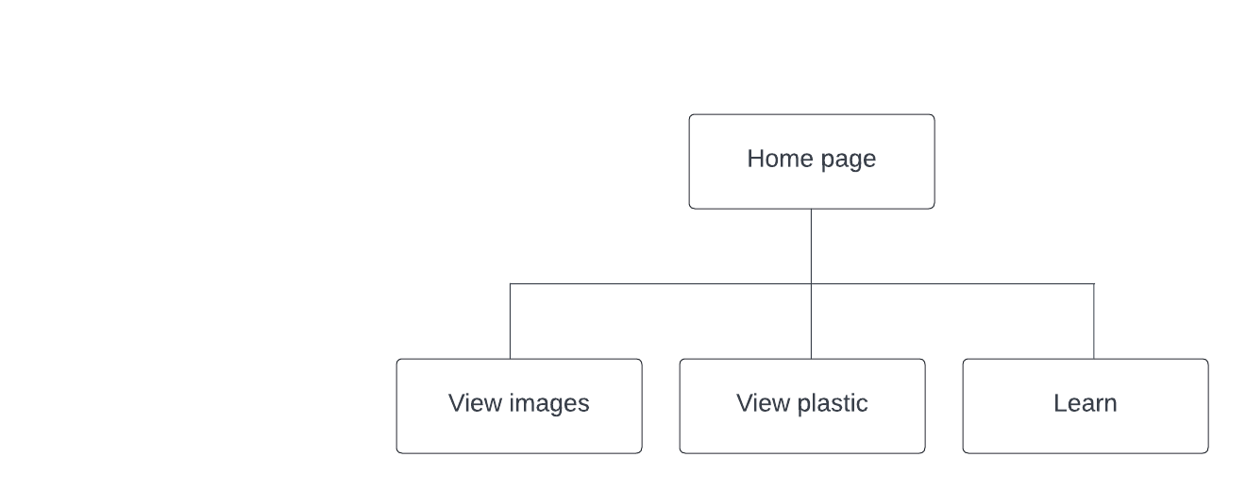

Figure 14: Pripod Webapp site map

### Flowchart

A flowchart is a diagrammatic representation of a programs algorithm. That is the contiguous steps taken to solve a problem.

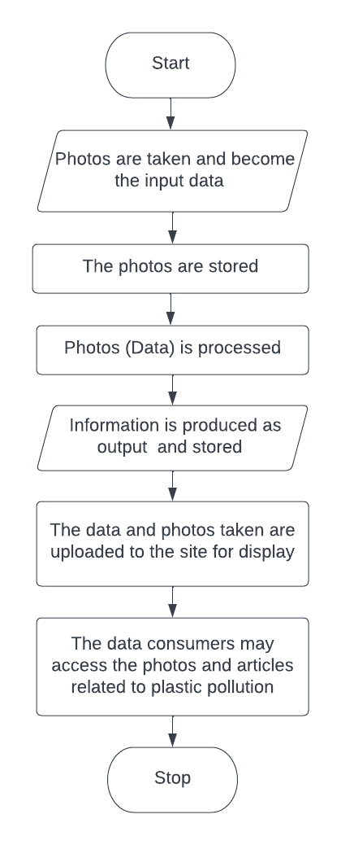

Figure 15: Pripod system flowchart

### Use Case Diagram

A use case diagram is a graphical depiction and summary of the various users’ interaction with the system.

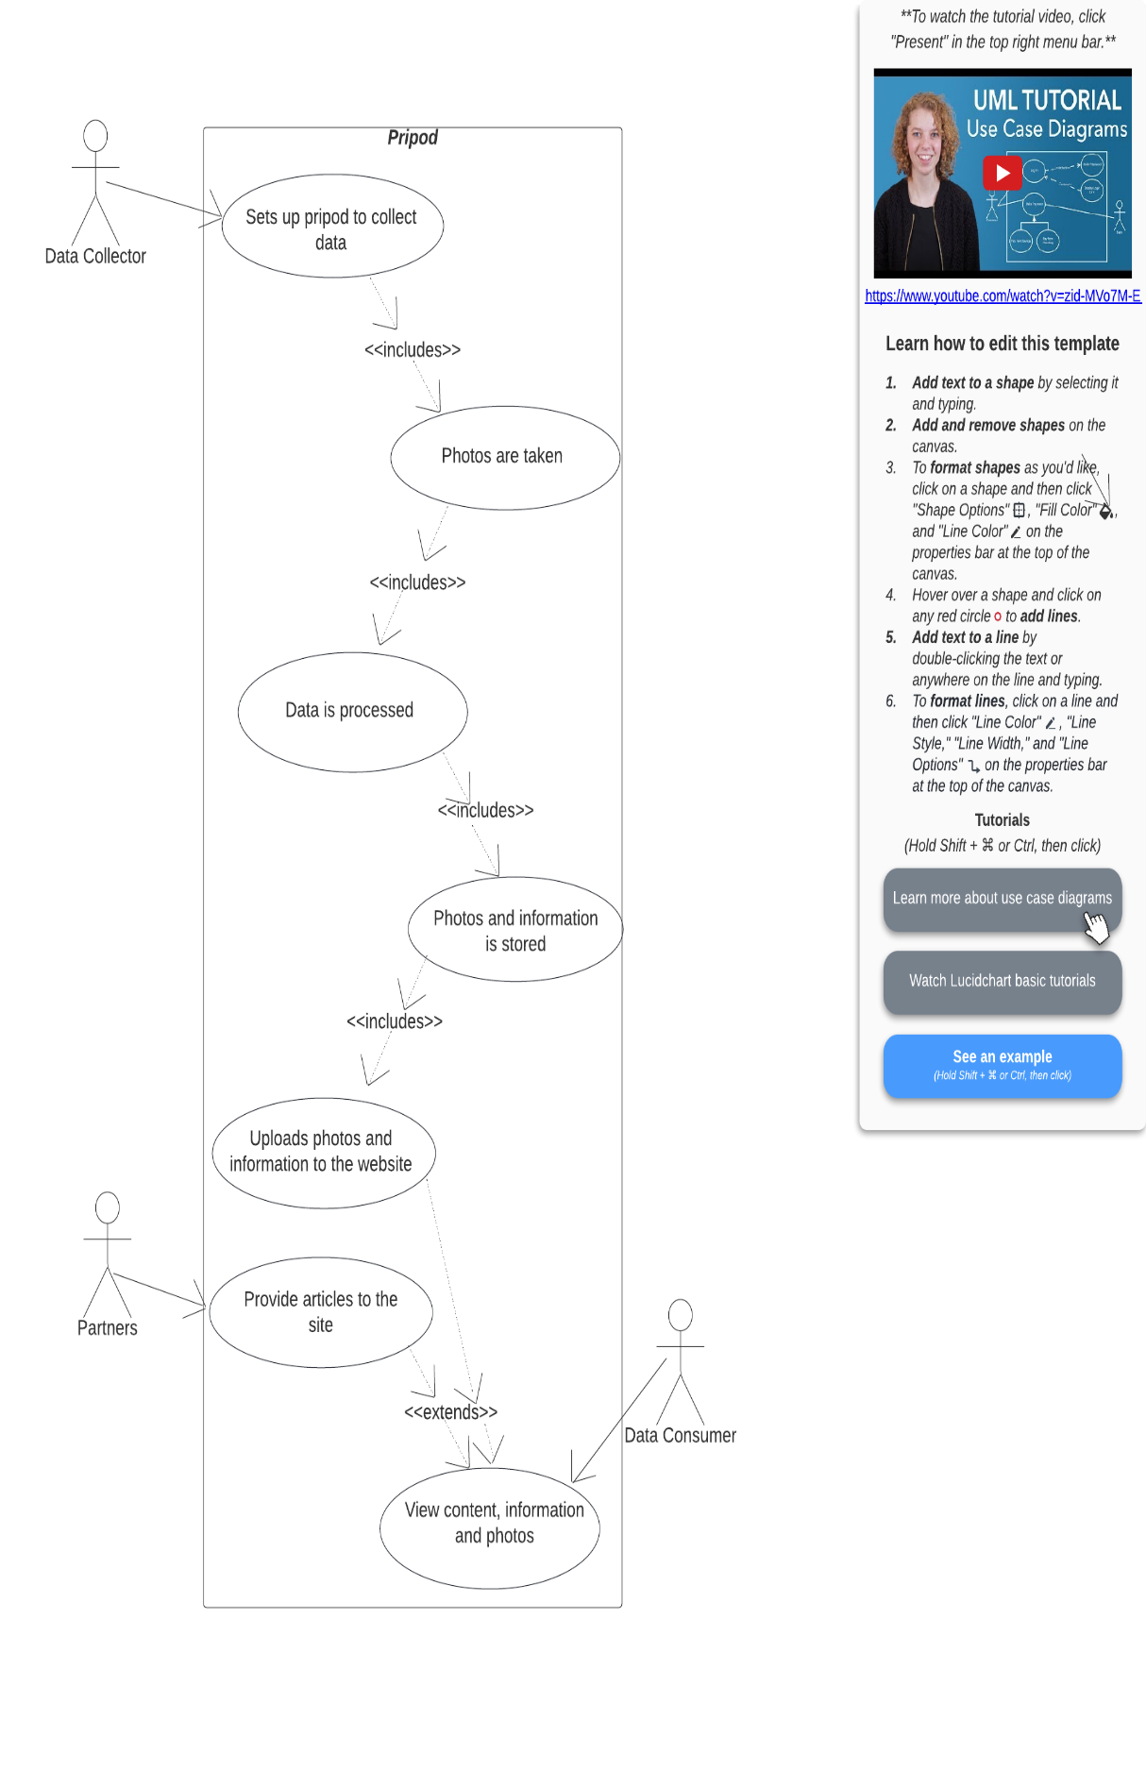

Figure 16: Pripod Use Case Diagram

### Sequence diagram

A sequence diagram is an interaction diagram that shows how operations are carried out in the system.

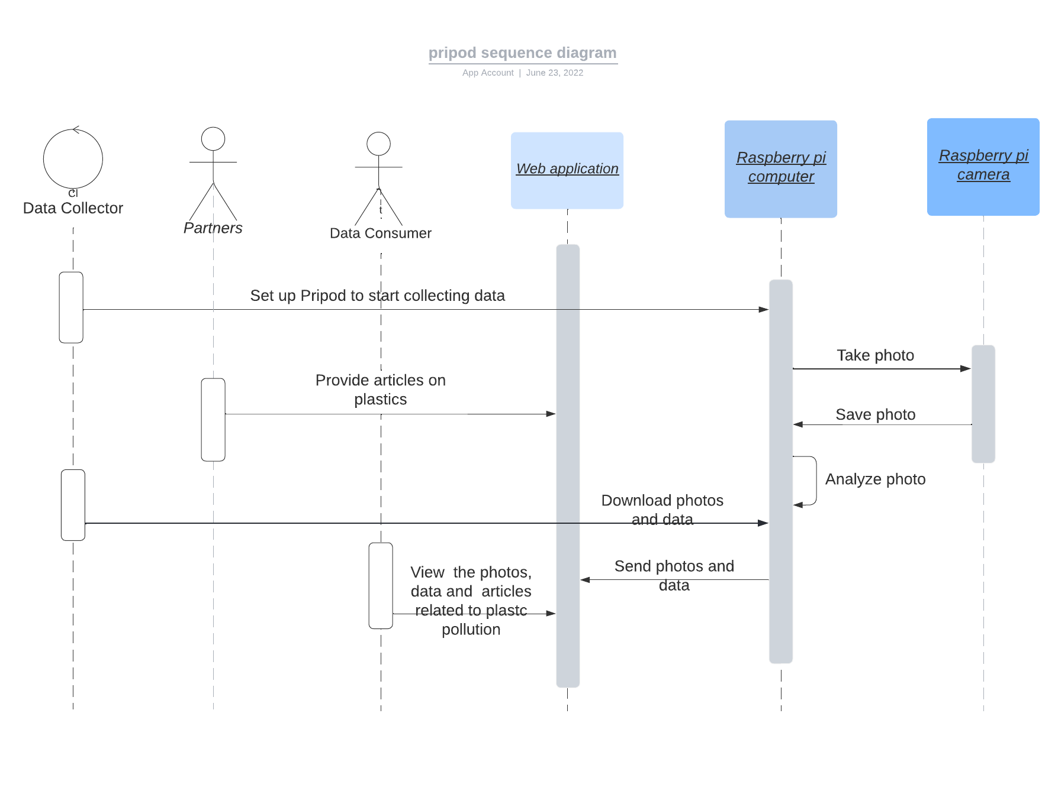

Figure 17: Pripod Sequence Diagram

### Data Flow Diagrams

These are representations of the flow of data and information through a system. They are 3, the contextual diagram also the level 0 DFD, the level 1 DFD and the level 2 DFD, they increase in showcasing how detailed the flow of the system is, from a level 0 DFD which is a very basic to the level 2 DFD that is more advanced and has better detail.

                  i.        Level 0 DFD (Contextual diagram)

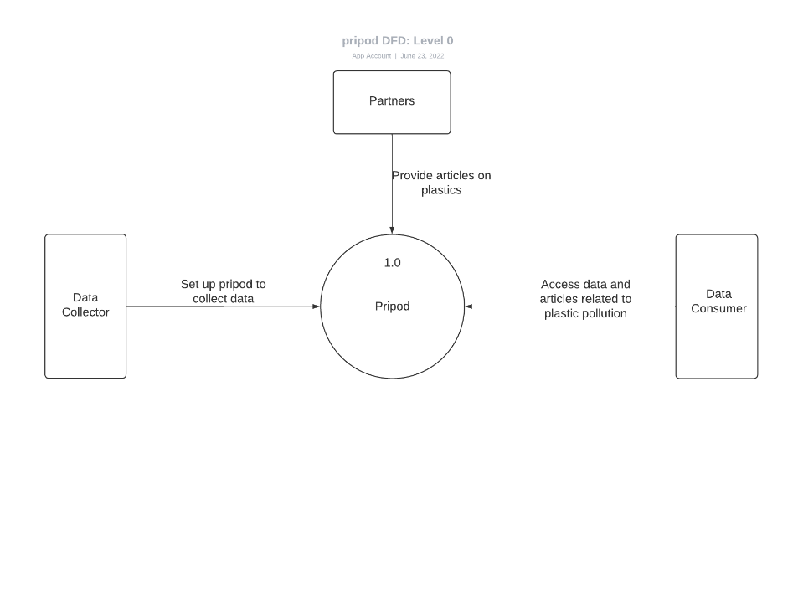

Figure 18: Pripod Level 0 DFD

                ii.        Level 1 DFD

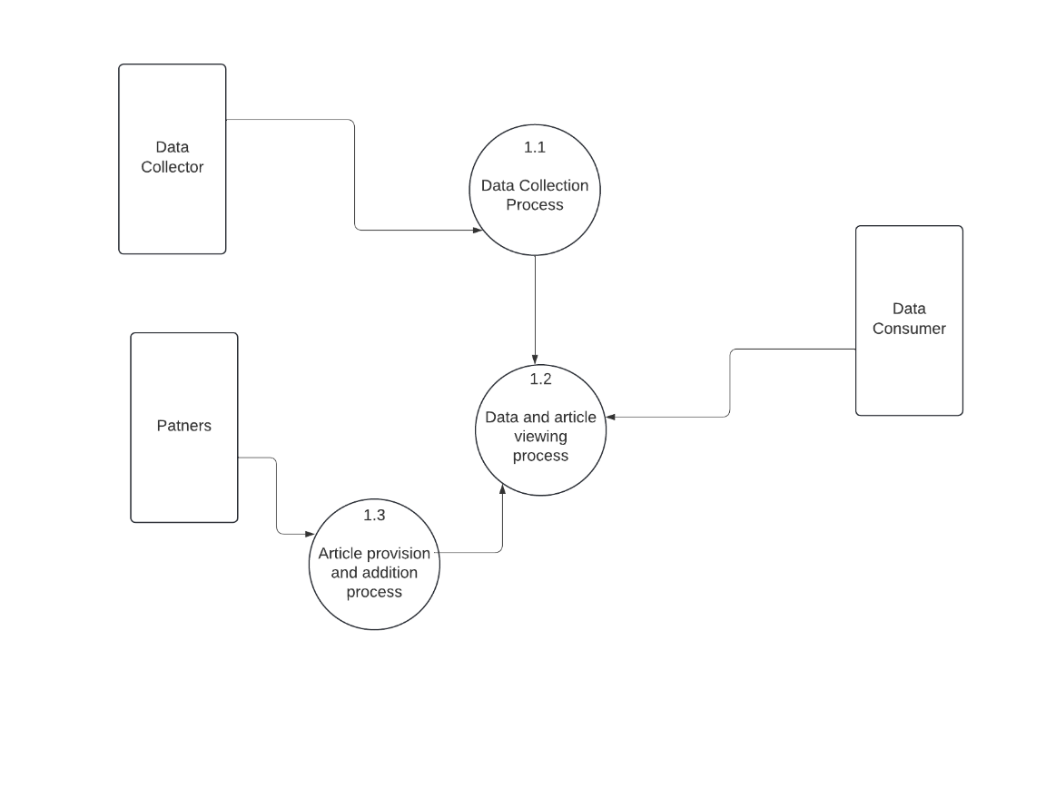

Figure 19: Pripod Level 1 DFD

               iii.        Level 2 DFD

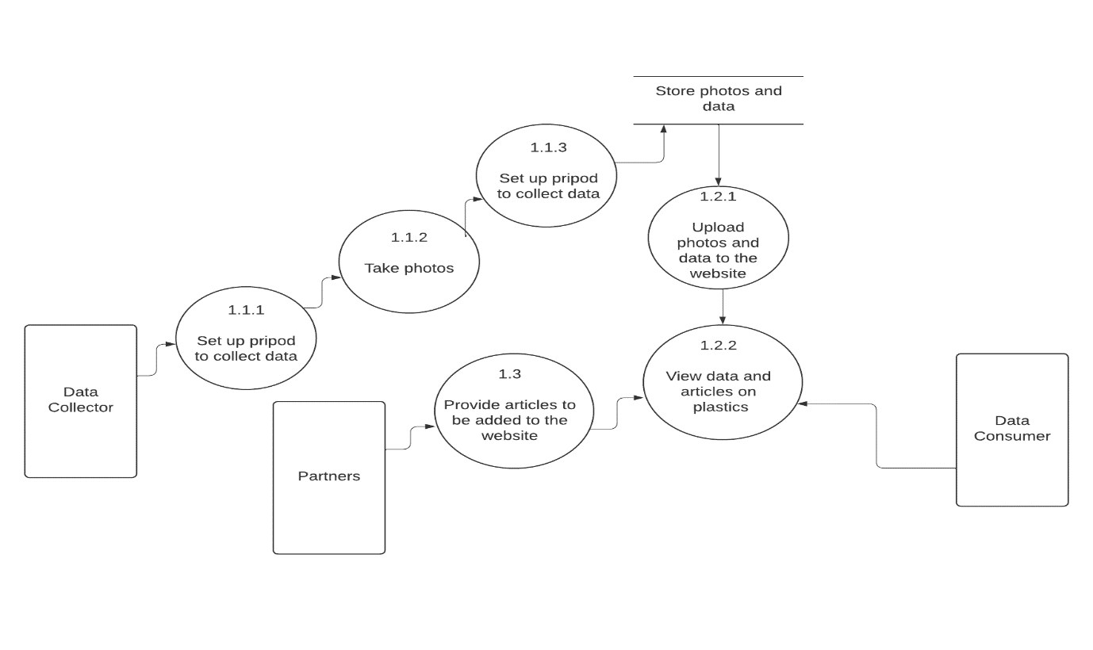

Figure 20: Pripod level 2 DFD



## User Interface design

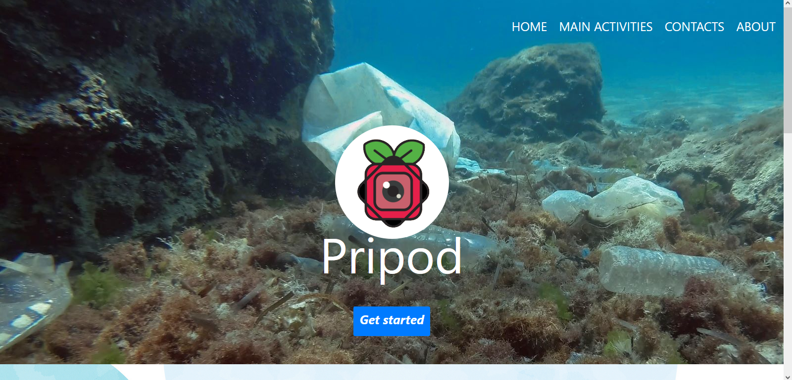

Figure 21: The first part of the landing page on the webapp

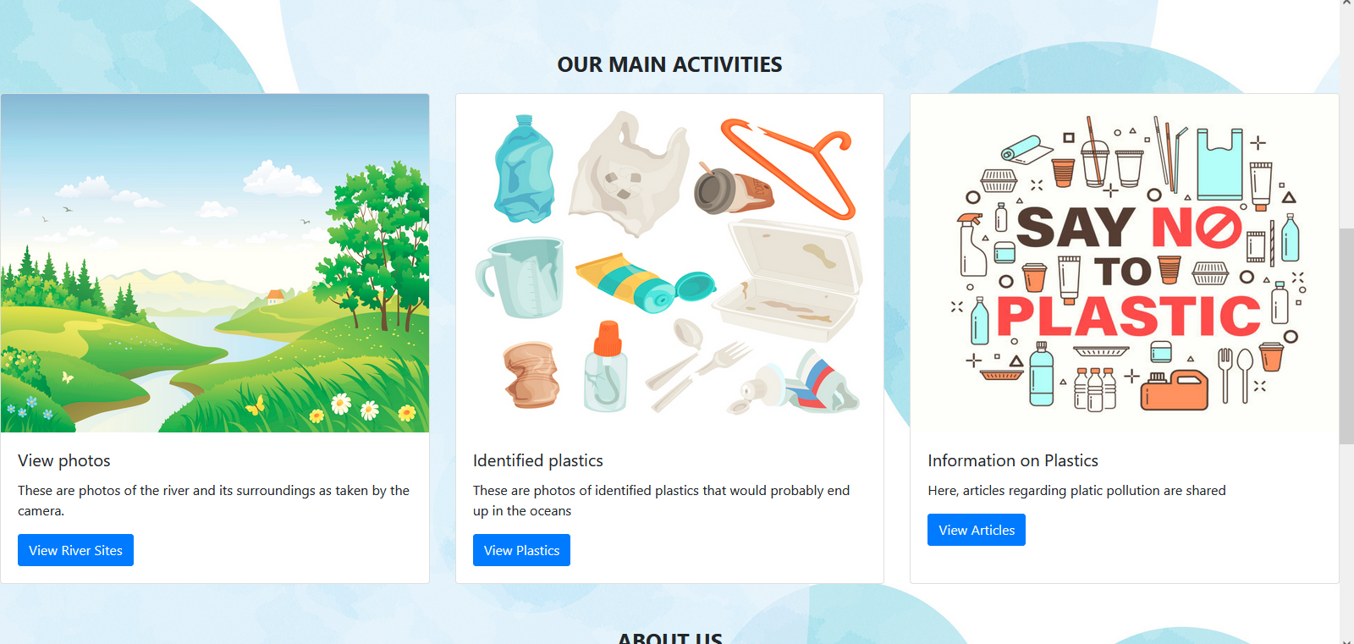

Figure 22: The second part of the landing page on the webapp

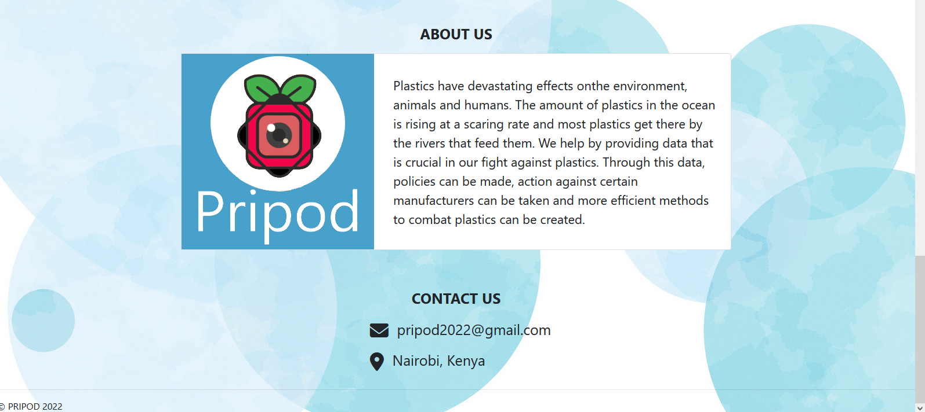

Figure 23: The third and final part of the landing page on the webapp

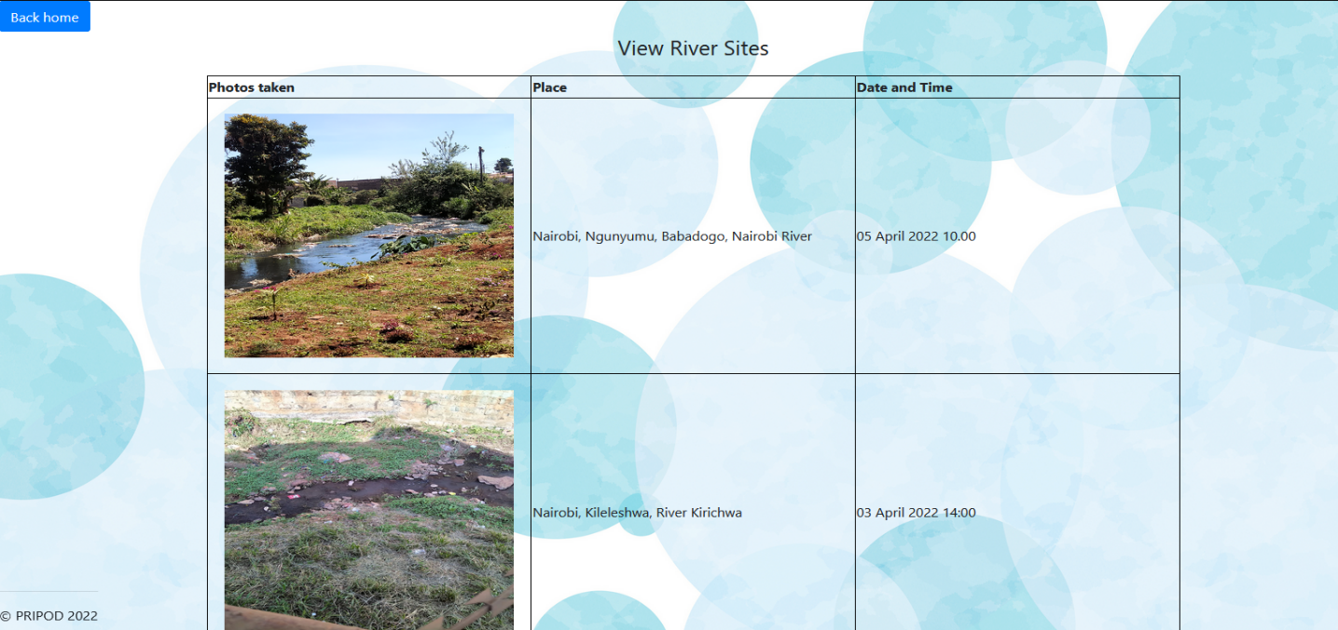

Figure 24: View river sites page

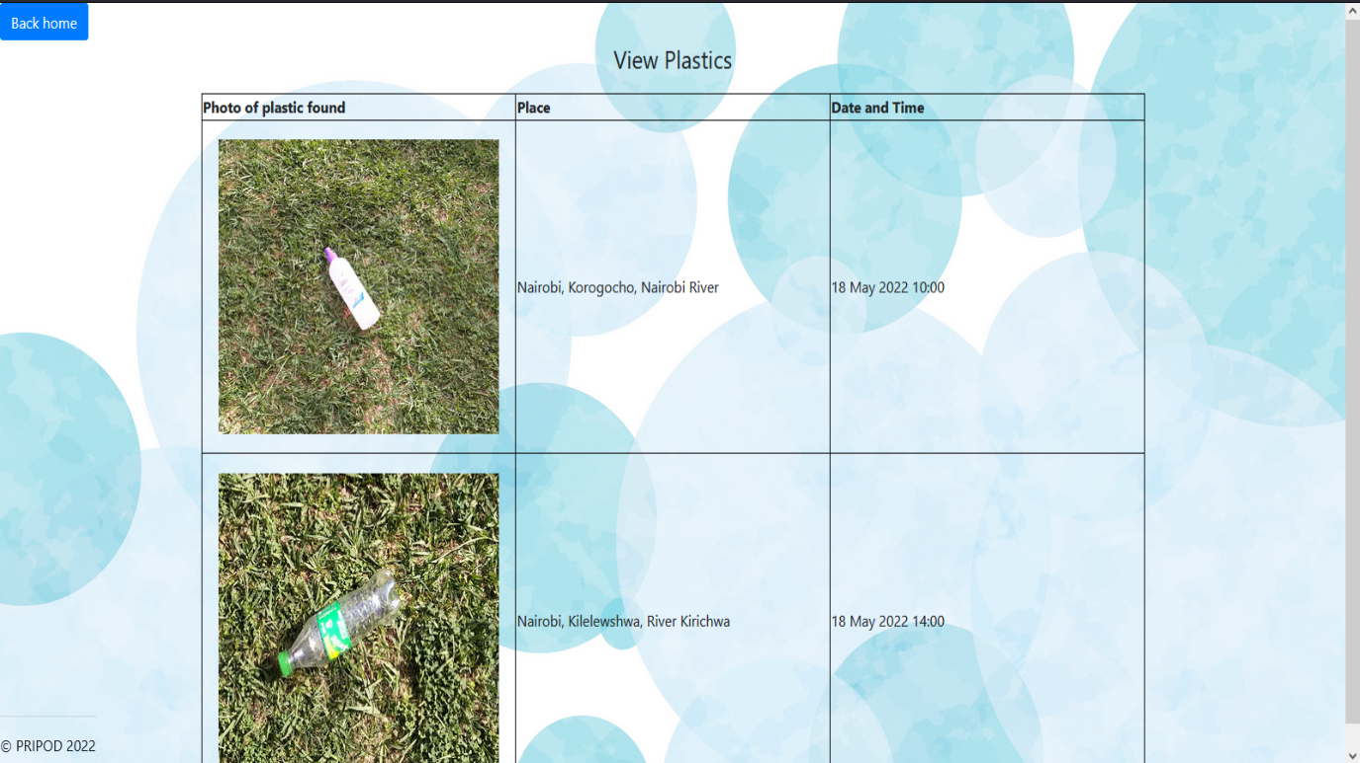

Figure 25: View plastics page

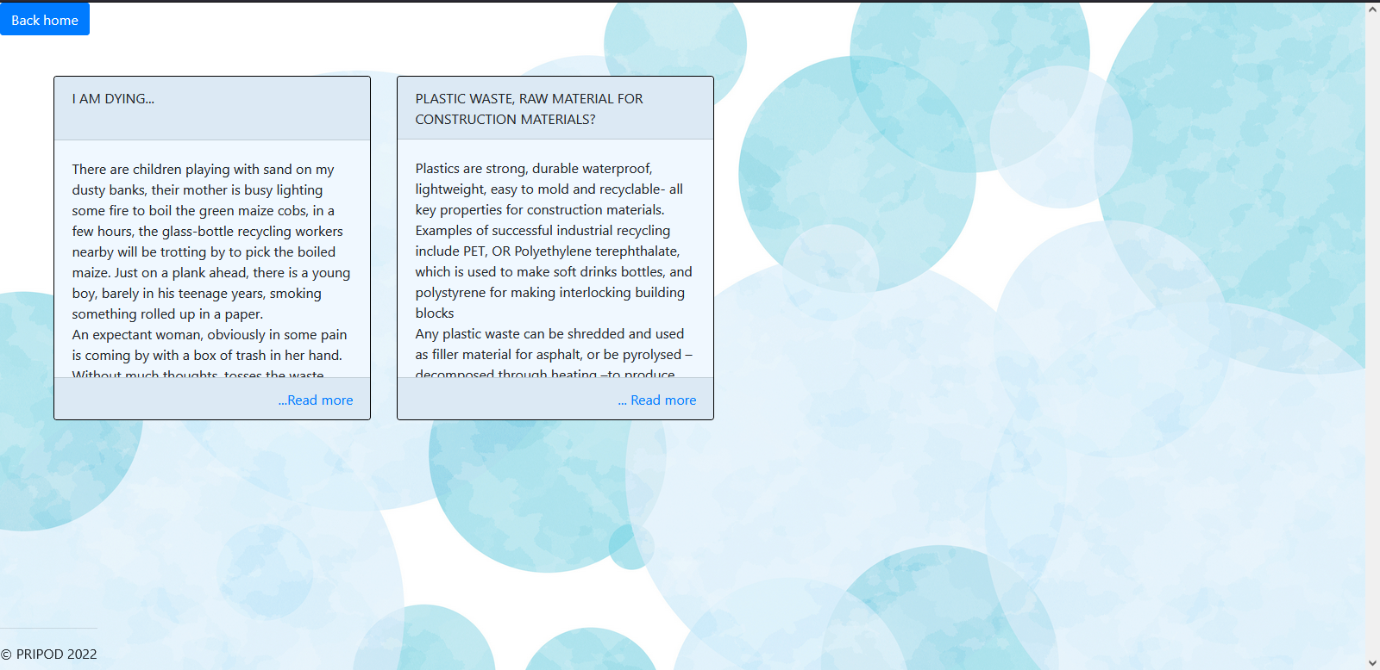

Figure 26: Learn page

# IMPLEMENTATION AND TESTING

## 5.1 Implementation

Within this chapter, the tools used in the development and implementation of the system are described.

### 5.1.1 Resources



#### 5.1.1.1 Hardware resources

On raspberry pi computer:

Raspberry pi 4B computer.

Arducam OV5647.

Raspberry Pi fan.

Connecting wires.

32 GB ScanDisk memory card.

Raspberry pi 4 case compatible with fan and camera (Yahboom acrylic case).

Canakit power cable connector.

On PC:

Lenovo X1 Carbon Think Pad.

Power cable connector.

#### 5.1.1.2 Software Resources

On raspberry pi computer:

Bullseye Raspbian OS 32 bit which comes with python 3.9 and Debian 11.

Visual Studio Code 1.65 on raspberry pi computer

Open CV version 4.5.5.

On PC:

Raspberry pi imager

Windows 10 OS

Visual Studio Code 1.67

Django version 3.2.

VNC viewer

On cloud:

Microsoft Azure.

Amazon s3 bucket for static file hosting

#### 5.1.2 Implementation of the two components of the system

The Raspberry pi Computer and Camera component:

1. I installed the Raspberry Pi Bullseye OS on the SD card using the raspberry pi imager.

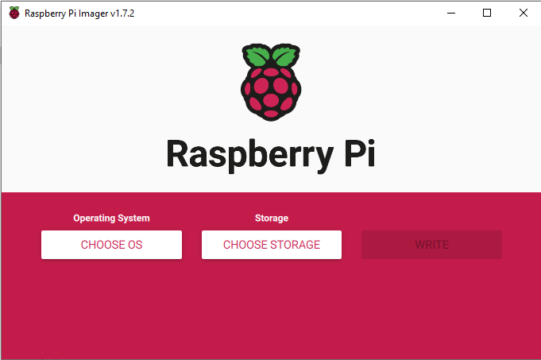

Figure 27: The Raspberry Pi imager

1. I set up the Raspberry pi computer for headless display, that is to display on any other screen other than the official raspberry pi display by creating and configuring the wpa_supplicant.config file of the created OS in Visual Studio Code, also creating an empty SSH folder so as to have the raspberry pi computer desktop displayed on my laptop virtually via VNC viewer application through a SSH connection.
2. I inserted the SDCard into the raspberry pi computer and installed VNC viewer in PC and in raspberry Pi so as to view the raspberry pi OS on my PC screen, as shown below.

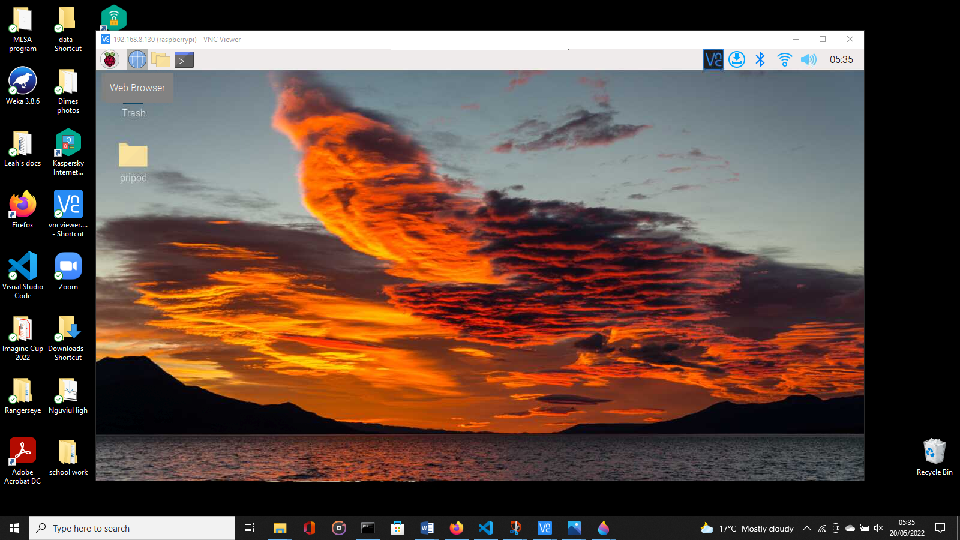

Figure 28: Bullseye OS desktop

1. I connected the camera (below diagram) to the raspberry pi computer by inserting part of the ribbon in the right port.

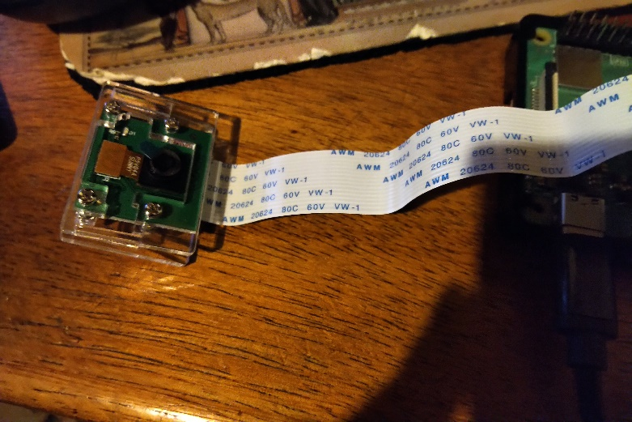

Figure 29: Raspberry pi camera

1. I installed Visual Studio Code and OpenCV with all its required dependencies.
2. I wrote code in Visual Studio code for OpenCV to detect plastics by template matching.

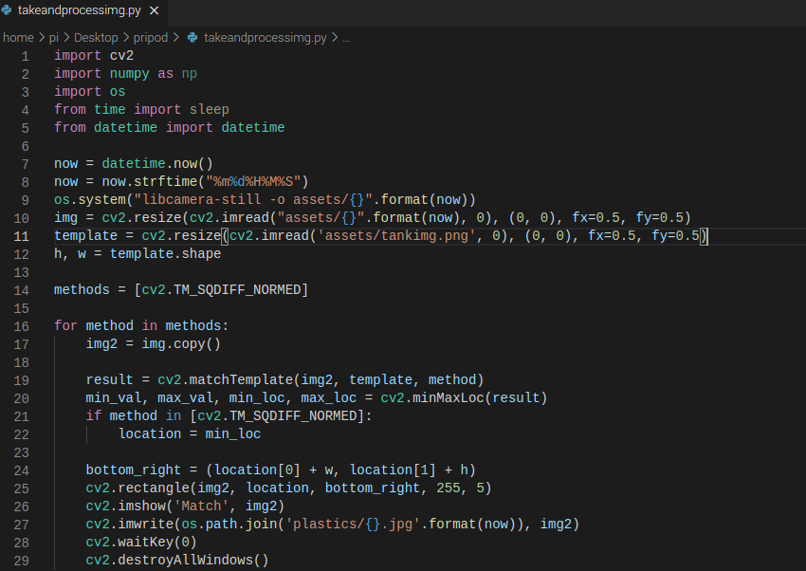

1. I assembled the case and added the fan so that it does not overheat and positioned the raspberry pi computer and camera in the case.

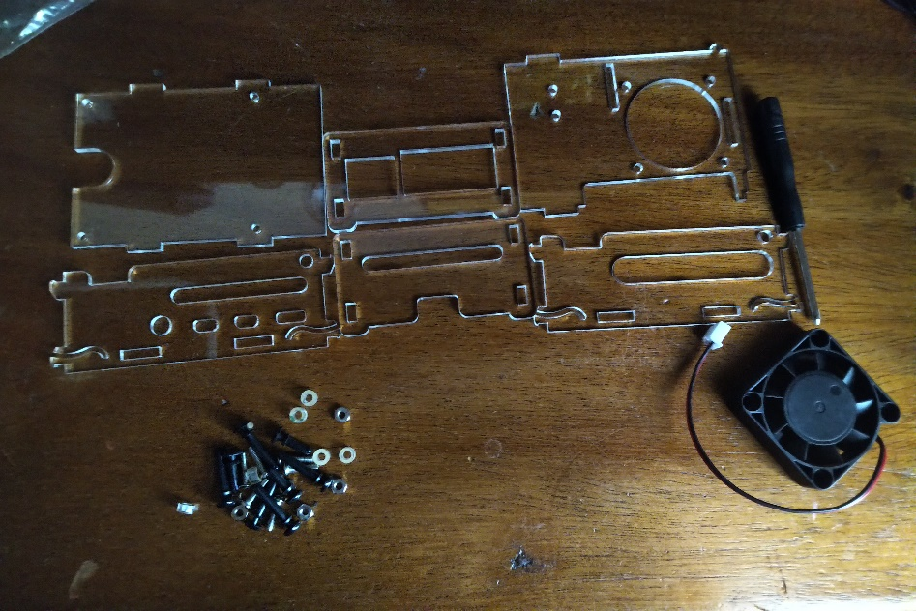

Figure 30: Assembly of case, Phase one

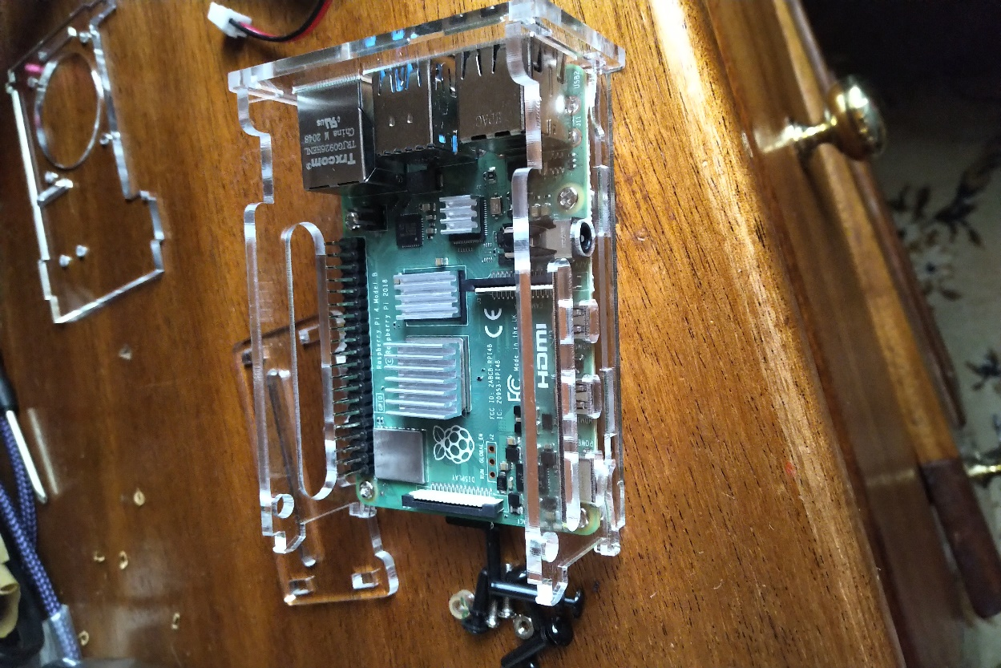

Figure 31: Assembly of parts, phase 2

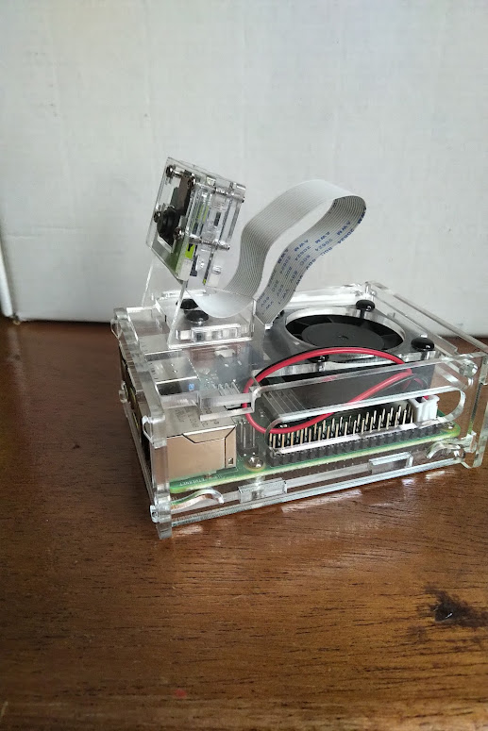

Figure 32: Assembly of case. Completion

The Pripod webapp:

1. I created a virtual environment and installed Django.
2. I wrote the HTML code for the different parts of the web app.

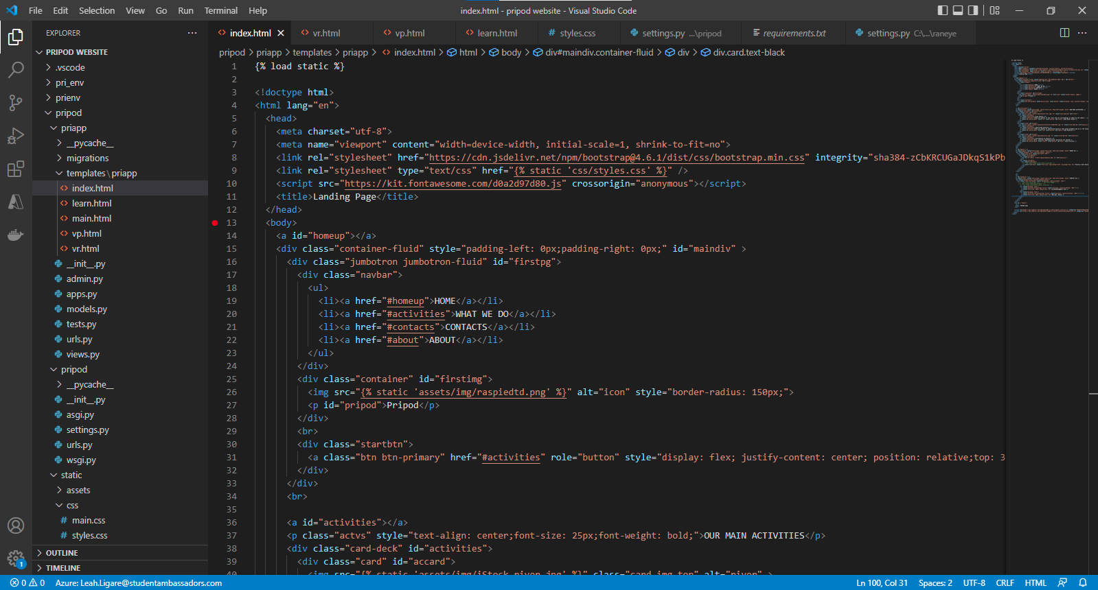

Figure 33: Beginning of index page html

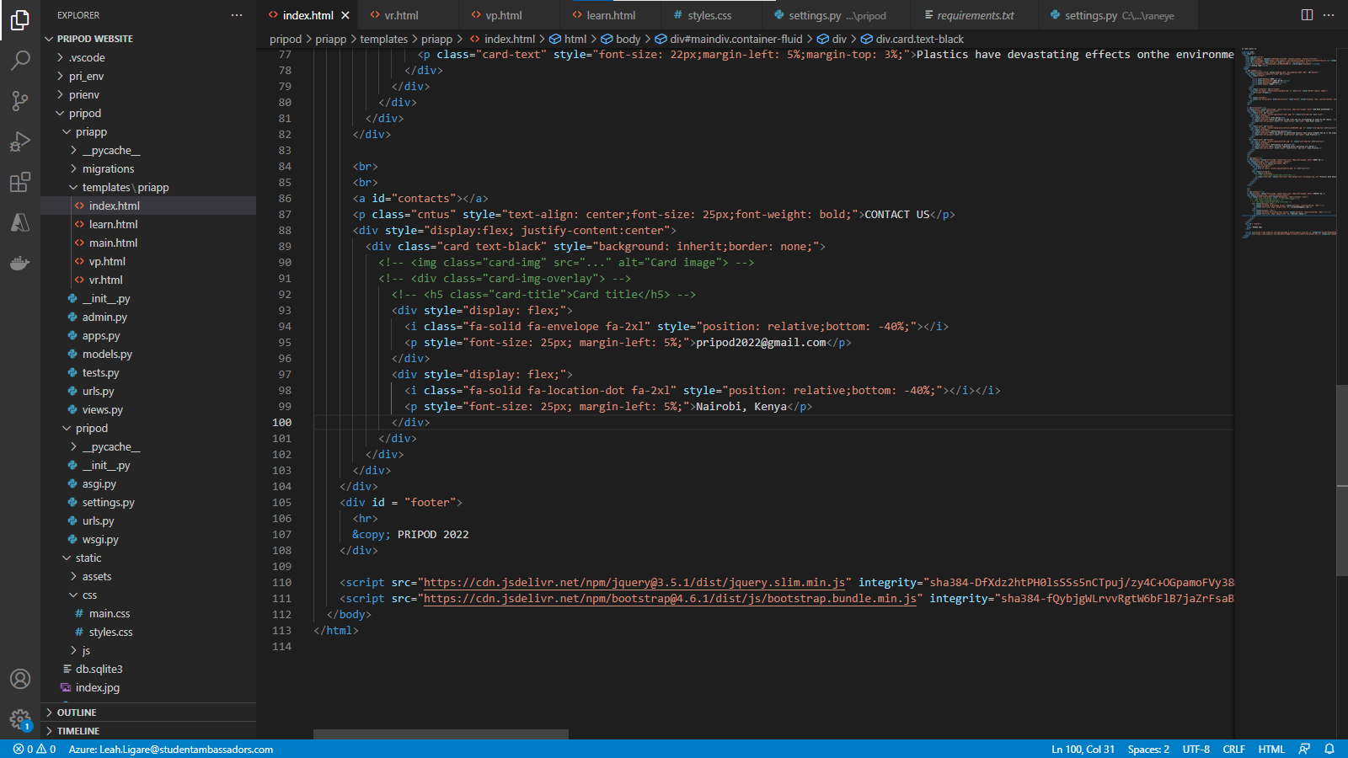

Figure 34: End of index page html

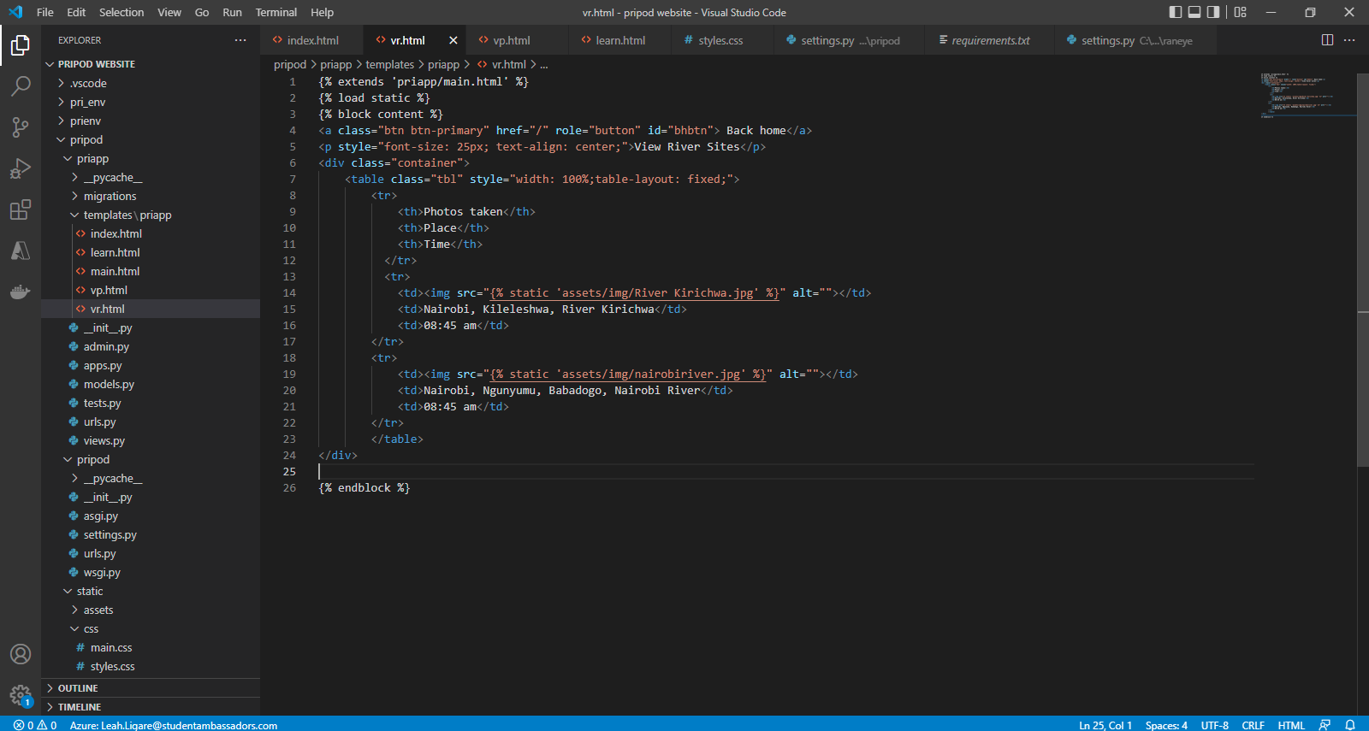

Figure 35: View river page html

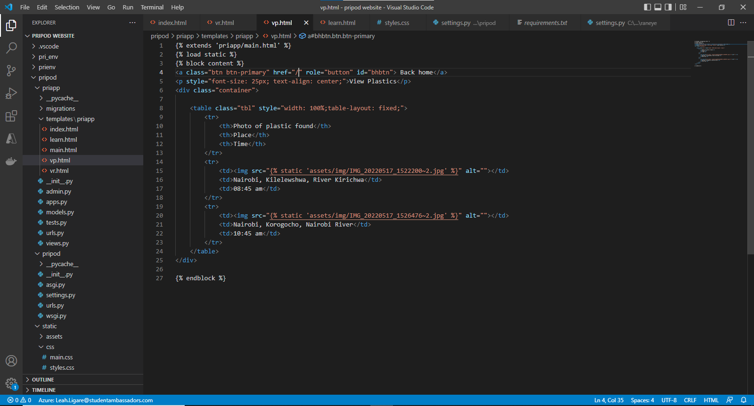

Figure 36: View plastic page html

1. I added CSS and bootstrap.

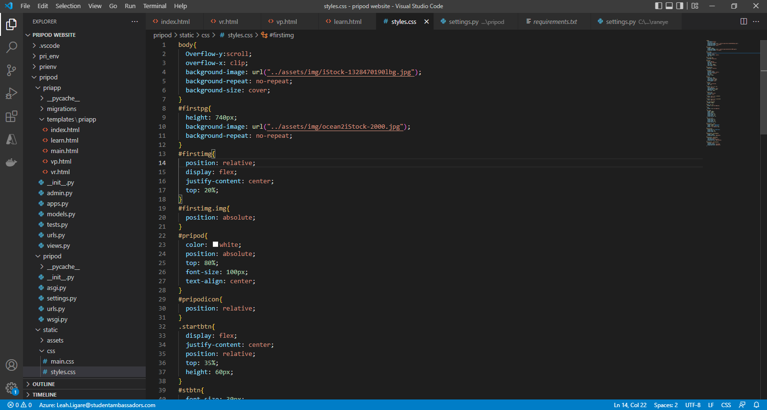

Figure 37: Css of webapp

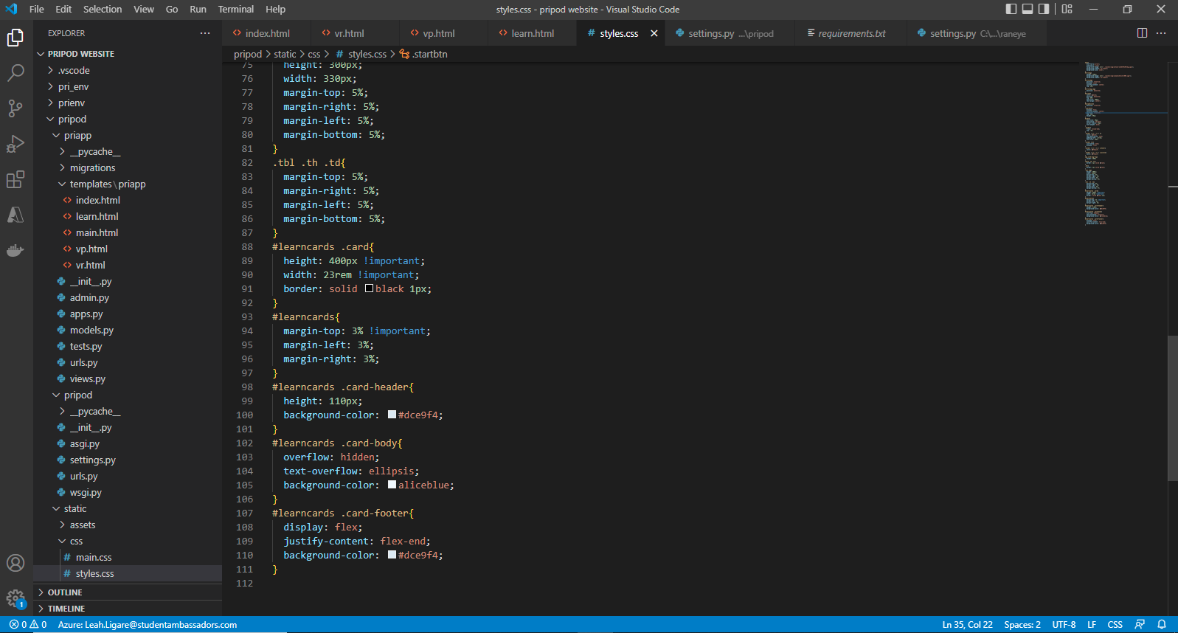

Figure 38: End of Css of webapp

1. I deployed the web app on Azure using Visual Studio Code to code and AWS to host the static files.

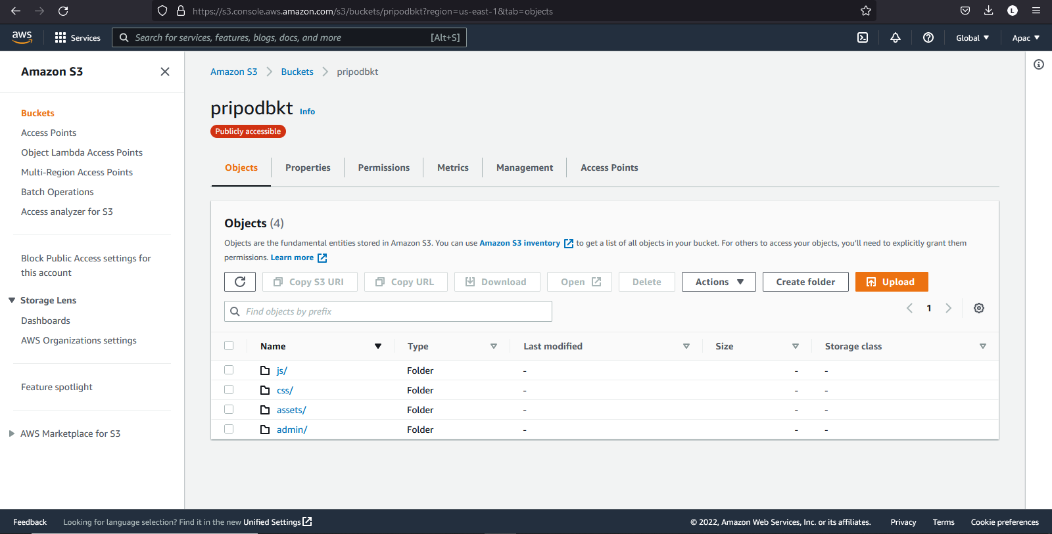

Figure 39: AWS S3 pripodbkt bucket

Results

1. The data collection model was able to detect plastics and save the information in files within the SDcard of the raspberry pi computer with the correct timestamps, though that is currently limited to the templates it is fed.
2. The camera was able to correctly detect templates within a 1 km range correctly with adequate lighting. TShat was between 6:30 am and 6:30pm using sunlight in the test environment.
3. Detected plastics could be uploaded to the Pripod website.

## 5.2 Testing

Testing focuses on how the modules that make up the system were tested, integrated to form an initial prototype and finally tested as an entire application. The following processes were performed during testing.

1. Unit Testing

2. Component Testing

3. System Testing

**1.   Unit Testing**

Unit testing tests each module that forms part of the system individually to ensure that they meet the requirements as a unit. This was done every time a module was developed to ensure that the module run as expected and would integrate with other modules well to form an error free application.

**2.   Component testing**

Component testing is where the different components, made up of many units are tested. Being made up of the smaller units that were already individually tested, this mainly entailed seeing how the different units worked together to form a component. Then testing if the component gave the expected output.

**3.   System Testing**

System testing involves the testing of the whole system, how all the components integrated to form the system and if it (the system) performs the required tasks. This was done using test data to see how the different components behaved together, debug any errors and confirm the outputs given were the expected ones.

# Conclusion



## Achievements

1. The raspberry computer and camera were assembled and run well with the Bullseye OS.
2. An openCV model with its dependencies was installed in the raspberry pi that allows the camera to identify objects through computer vision.
3. A data collection system was made using raspberry pi that allows for one to detect plastics through template matching.
4. The website was created and deployed to the cloud.

## Limitations

The system is not optimised and can be improved in many ways such as automating the whole data collection process and sending photos directly to the site if network is available, delaying if it is not.

## Future plans

Utilize more technologies to optimize the system, grow in experience and attain much better results then scale to more parts within the world.

## Recommendations

The system should be automated and improved in other ways then released to the market as soon as possible so as to collect data and aid the fight against ocean plastic pollution.

## Conclusion

The system meets the need of a plastic data collection system and can be improved in various ways to bring out the best in the system, facilitating the clean-up of rivers hence preventing plastics from reaching the oceans.

# REFERENCES

1. IBM. *What is Computer Vision?* May 2022. <https://www.ibm.com/topics/computer-vision>.Last accessed in May, 2021.
2. IUCN. *Marine plastic pollution*. 5 May 2018. <https://www.iucn.org/resources/issues-briefs/marine-plastic-pollution#menu>.Last accessed in May, 2021
3. —. *Marine Plastic Pollution*. 17 November 2021. <https://www.iucn.org/resources/issues-briefs/marine-plastic-pollution>. Last accessed in May, 2022.
4. Parker, Laura. “Plastic gets to the oceans through over 1,000 rivers.” 30 April 2021. *Natural Geographic.* <https://www.nationalgeographic.com/environment/article/plastic-gets-to-oceans-through-over-1000-rivers>. Last accessed in May 2022.
5. —. *Plastic trash flowing into the seas will nearly triple by 2040 without drastic action*. 23 July 2020. <https://www.nationalgeographic.com/science/article/plastic-trash-in-seas-will-nearly-triple-by-2040-if-nothing-done>. Last accessed in May 2022.
6. Plastic Soup Foundation. *More plastic than fish*. 3 September 2019. <https://www.plasticsoupfoundation.org/en/plastic-problem/plastic-soup/more-plastic-than-fish/>. Last accessed in May 2022.
7. —. *Plastic Facts and Figures*. 27 May 2021. <https://www.plasticsoupfoundation.org/en/plastic-facts-and-figures/>. Last accessed in May 2022.
8. Raspberry Pi Tips. *The epci story of the Raspberry Pi*. 2022. <https://raspberrytips.com/raspberry-pi-history/>. Last accessed in May 2022.
9. Rozsa, Matthew. *salon*. 10 April 2021. <https://www.salon.com/2021/04/10/how-plastic-pollution-threatens-our-health-food-systems-and-civilization-itself/>. Last accessed in May 2022.
10. The Raspberry Pi foundation. *Main site*. n.d. <The Raspberry Pi foundation>. Last accessed in May 2022.
11. Thompson, Andrea. *Earth Has a Hidden Plastic Problem—Scientists Are Hunting It Down*. 13 August 2018. <https://www.scientificamerican.com/article/microplastics-earth-has-a-hidden-plastic-problem-mdash-scientists-are-hunting-it-down/>. Last accessed in May 2022.
12. Tim Van Emmerick, Anna Schwarz. *Plastic debris in rivers*. 29 November 2019. <https://wires.onlinelibrary.wiley.com/doi/full/10.1002/wat2.1398>. Last accessed in May 2022.
13. Wikipedia. *OpenCV*. 16 June 2005. <https://en.wikipedia.org/wiki/OpenCV>. Last accessed in February 2022.

# APPENDICES

## User Manual

If the user is a data consumer.

1. The user may access the website by navigating to the website <https://pripodwebapp.azurewebsites.net/> on their chosen browser. This directs them to the landing page shown below.



Figure 40: Landing page (1st section)

1. The user may choose to move to the other parts of the page by clicking on their links at the top right section of the page or by scrolling down to the section using the scroll bar on the extreme right of the page.

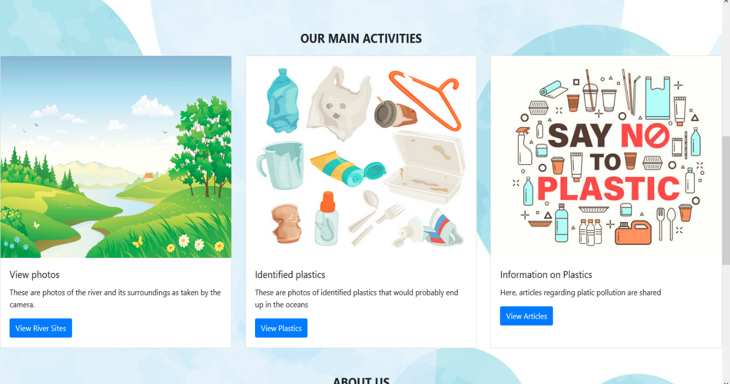

Figure 41: Landing page (2nd section)



Figure 42: Landing page (3rd and last part)

1. The user may freely access photos taken at the river sites, the plastics collected, that is where and when a certain type of plastic is collected and access articles related to plastic pollution by clicking on the MAIN ACTIVIES link on the navigation bar located on the top right corner of the page or by scrolling down to the section and clicking on the button.



Figure 43: Main activities section

1. At this section the buttons will direct the user to the following pagers, in their respective order. To be directed back to the home page, the user may use the back button of their browser or press on the go back button on the top left of the page.

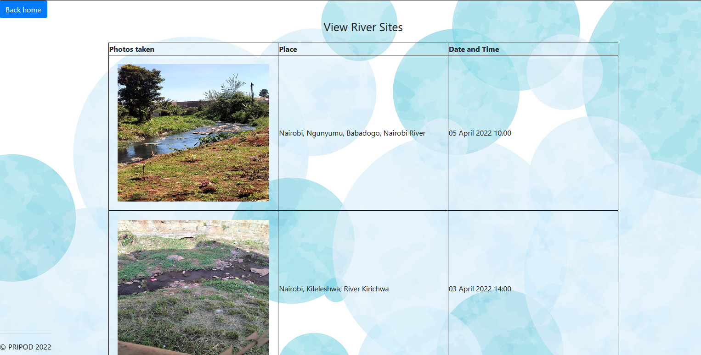

Figure 44: View river sites page



Figure 45: View plastics page.



Figure 46: Learn page

If the user is a data collector.

1. The user is required to load templates to the system, if the template of what the type of plastic to be identified is not available in the system some examples that have been used are a bottle, sanitizer and tank.
2. Once done, the user should set up the camera at an ideal place so as to collect data. A place that is within the range of 1 km of the plastics.
3. The photos will then be taken and the user then uploads that data to the site <https://pripodwebapp.azurewebsites.net/> whose usage has been explained in the section above.

## GLOSARY

A.I – The simulation of human intelligence by machines.

Big Data - Data that contains greater variety, arriving in increasing volumes and with more velocity.

IoT – Physical objects and technologies that connect and exchange data with other devices and systems over the Internet or other communications networks.

M.L – A subset of AI that focuses on building systems that learn or improve their performance based on the data they consume.

SSH- The Secure Shell Protocol is a cryptographic network protocol for operating network services securely over an unsecured network. Its most notable applications are remote login and command-line execution.

Static files – In Django, these are files that are needed for the web application to run smoothly but are not python files such as images.

Template – In this document is a type of plastic, an object that is similar in size and shape to the plastics that are to be detected.

VNC - Virtual Network Computing is a graphical desktop-sharing system that uses the Remote Frame Buffer protocol to remotely control another computer.